

)كلية الحاسبات وتكنولوجيا المعلومات (جنوب الوادي)

College of Computing and Information Technology (South Valley)

B. Sc. Final Year Project

(CS401 PROJECT-I)
AI Healthcare Skin Cancer Detector
نظام ذكاء اصطناعي للكشف عن سرطان الجلد

Presented By:
Abdallah Mohammed El Modather | Ahmed Hassan Mahmoud
Ahmed Kenawy Mohammed | Hamza Mamdouh Ahmed
Khaled Mohammed Saleh | Mohammed Khaled Amine
Yousef Hassan Hamouda

Supervised By:

Ass. Prof. Mohammed Abdel Hamid

Aswan, EGYPT

(2026)

Declaration
I hereby certify that this report, which I now submit for assessment on the programme of study leading to the award of Bachelor of Science in Computing and Information Technology, is all my own work and contains no Plagiarism. By submitting this report, I agree to the following terms:
Any text, diagrams or other material copied from other sources (including, but not limited to, books, journals, and the internet) have been clearly acknowledged and cited followed by the reference number used; either in the text or in a footnote/endnote. The details of the used references that are listed at the end of the report are confirming to the referencing style dictated by the final year project template and are, to my knowledge, accurate and complete.
I have read the sections on referencing and plagiarism in the final year project template. I understand that plagiarism can lead to a reduced or fail grade, in serious cases, for the Graduation Project courses.
Student1 Name: Abdallah Mohammed El Modather  Registration Number:  Signed: Abdallah Mohammed El Modather  Date: DD – MMM – YYYY | Student 2 Name: Ahmed Hassan Mahmoud  Registration Number: 221008609  Signed: Ahmed Hassan Mahmoud  Date: DD – MMM – YYYY
Student 3 Name: Ahmed Kenawy Mohammed  Registration Number: 221008564  Signed: Ahmed Kenawy Mohammed  Date: DD – MMM – YYYY | Student 4 Name: Hamza Mamdouh Mohammed  Registration Number: 221008857  Signed: Hamza Mamdouh Mohammed  Date: DD – MMM – YYYY
Student 5 Name: Khaled Mohammed Saleh  Registration Number:221008557  Signed: Khaled Mohammed Saleh  Date: DD – MMM – YYYY | Student 6 Name: Mohammed Khaled Amine  Registration Number: 221008774  Signed: Mohammed Khaled Amine  Date: DD – MMM – YYYY

Student 7 Name: Youssef Hassan Hamouda

Registration Number: 221018110

Signed: Youssef Hassan Hamouda

Date: DD – MMM – YYYY

Students Contribution
AI Healthcare Skin Cancer Detector

By:
Abdallah Mohammed El Modather
Ahmed Hassan Mahmoud
Ahmed Kenawy Mohammed
Hamza Mamdouh Ahmed
Khaled Mohammed Saleh
Mohammed Khaled Amine
Yousef Hassan Hamouda
Chapter | Title | Contributors
1 | Introduction | Abdallah Mohammed El Modather  Ahmed Hassan Mahmoud  Ahmed Kenawy Mohammed
2 | Background and Literature review | Hamza Mamdouh Ahmed  Khaled Mohammed Saleh  Mohammed Khaled Amine  Yousef Hassan Hamouda
3 | Proposed System | Hamza Mamdouh  Khaled Mohammed  Mohammed Khaled  Yousef Hassan Hamouda
4 | Skin Disease Classification Model | Yousef Hassan Hamouda
5 | Initial Results and Discussions | Hamza Mamdouh Ahmed
6 | Conclusions and Future Works | Mohammed Khaled Amine
7 | References | Abdallah Mohammed El Modather  Ahmed Hassan Mahmoud  Ahmed Kenawy Mohammed  Hamza Mamdouh Ahmed  Khaled Mohammed Saleh  Mohammed Khaled Amine  Yousef Hassan Hamouda
Abstract
This project outlines the development of a mobile application that uses machine learning models trained on publicly available dermoscopic image datasets as well as current melanoma literature from 2018 to 2025 to detect suspicious skin lesions. This project required the gathering of images from publicly available sources (such as the ISIC challenge datasets), the development of the application, the development of the application's algorithm, as well as the development of the application itself. This application would take images of the lesion, run the image through the algorithm, and give the user a risk assessment as well as suggestions as to the best course of action. Validation of the application would have been done using the test dataset as well as the initial images gathered. This application would have been presented in such a manner as to ensure that the user would understand that the application is simply a tool for determining the probability of a lesion being melanoma, but not a definitive means of determining the existence of melanoma. This project would have shown that a well-validated application can be developed using current literature, but that further testing in a clinical setting would be necessary before such an application could be used in the medical field.
Table of Contents
1 Introduction 1
1.1 Motivations 2
2 Background and Literature review 3
2.2 Skin cancer diagnosis based on deep transfer learning and sparrow search algorithm 5
2.3 Detection of Malignant Melanoma Using Artificial Intelligence: An Observational Study of Diagnostic Accuracy 6
2.4 The future of skin cancer diagnosis: a review of machine learning and deep learning models 6
2.5 Early detection of skin cancer is crucial for successful treatment and improved patient outcomes 7
2.6 Melanoma Skin Cancer Detection Using Ensemble of Machine Learning Models Considering Deep Feature Embedding 7
2.7 A Bibliometric Review of Deep Learning Approaches in Skin Cancer Research 8
2.8 Deep learning techniques for skin lesion analysis and melanoma cancer detection a survey of state-of-the-art 8
2.9 Design and validation of a new machine-learning-based diagnostic tool for the differentiation of dermatoscopic skin cancer images 9
2.10 New Trends in Melanoma Detection Using Neural Networks: A Systematic Review 11
2.12 Skin Melanoma Detection Based on Machine Learning 12
2.13 Automatic lesion segmentation using atrous convolutional deep neural networks in dermoscopic skin cancer images 12
2.14 A Review on Transfer Learning Approaches for Skin Melanoma Classification 13
2.15 Identifying Candidates for Immunotherapy among Patients with Non-Melanoma Skin Cancer: A Review of the Potential Predictors of Response 14
3 Proposed System 16
3.1 System Architecture 16
3.2 AI Model 17
3.2.1 Artificial Intelligence Model Description 17
3.2.2 Skin Lesion Segmentation Model 17
3.2.3 Skin Lesion Classification Model 17
3.2.4 Dataset Description 18
3.2.5 Data Preprocessing and Augmentation 18
3.2.6 Model Training and Evaluation 18
3.2.7 Model Architecture 18
3.2.8 Deployment Architecture 20
3.3 Frontend Implementation 21
3.3.1 Technologies Used 21
3.3.2 Project Structure 21
3.3.3 Main Screens 22
3.3.4 Important Code Snippets 24
3.4 Backend Implementation 27
3.4.1 Backend Architecture 27
3.4.2 Database Design 28
3.4.3 API Endpoints 31
3.4.4 Authentication 35
3.4.5 AI Integration 38
3.4.6 AWS Deployment 40
3.5 ERD 41
3.6 Data Flow Diagram 42
3.6.1 Context Level 42
3.6.2 Level 1 42
3.6.3 Level 2 43
3.7 Use Case 44
3.7.1 Application of Use Case Diagram 44
3.7.2 Use Case Scenarios 45
4 Skin Disease Classification Model 48
4.1 Experimental Setup 48
4.1.1 Train/Test Split 48
4.2 Segmentation Results 49
4.2.1 Segmentation Results 49
4.3 Classification Results 49
4.3.1 Training Curves and Class-wise Accuracy 50
4.3.2 Sample Prediction 51
4.4 Confusion Matrix 52
4.5 ROC Curve and AUC 53
4.5.1 AUC Values by Class 53
4.6 Performance Analysis 54
4.7 Comparison with Previous Studies 54
5 Initial Results and Discussions 55
5.1 Prototype Initial Result 55
5.2 Welcome page 55
5.2.1 Welcome to 55
5.2.2 Login 56
5.2.3 Forget password 57
5.2.4 Recreate new password 58
5.2.5 Register 59
5.2.6 Confirm email 60
5.2.7 Homepage 61
5.2.8 scan 62
5.2.9 AI detect details 63
5.2.10 Share 64
5.2.11 Lesions 65
5.2.12 Confirm delete 66
5.2.13 Profile page 67
5.2.14 Mood 68
6 Conclusion and Future Work 69
6.1 Conclusions 69
6.2 Future Work: 69
7 References 70

List of Figures
Figure 1 Samples from the used datasets 5
Figure 2 The top 20 most wrong predictions. 10
Figure 3 Comparison of networks 13
Figure 4 Architecture of the project 16
Figure 5 U-Net-1 18
Figure 6 U-Net-2 19
Figure 7 U-Net-3 19
Figure 8 U-Net-4 19
Figure 9 Confidential 20
Figure 10 Deployment Architecture 20
Figure 11 Project Structure 21
Figure 12 Home Page 22
Figure 13 Profile Page 22
Figure 14 Setting Page 22
Figure 15 Education Page 22
Figure 16 Scan Lession Page P1 23
Figure 17 Scan Lession Page P2 23
Figure 18 Scan Result Page p1 23
Figure 19 Scan Result Page P2 23
Figure 20 Main Screens Table 23
Figure 21 Main Page 24
Figure 22 Image Analysis 25
Figure 23 Result Page 26
Figure 24 Backend Architecture 27
Figure 25 Database Collections 28
Figure 26 User Collection 29
Figure 27 Skin Analysis Collection 29
Figure 28 Recommendations Collections 30
Figure 29 Authentication Workflow 35
Figure 30 AI Integration Workflow 38
Figure 31 AWS Deployment 40
Figure 32 ERD of Proposed System 41
Figure 33 DFD context level (level 0) 42
Figure 34 DFD Level 1 42
Figure 35 DFD Level 2 43
Figure 36 User Use Case 44
Figure 37 Example of a pigmented facial lesion (illustrative image only — not a model input/output sample). 49
Figure 38 shows us the training loss and validation loss for our model well as the accuracy over a number of epochs. It also includes a confusion matrix and the accuracy for each class. The training loss and validation loss are important to look at because they ttell us how well our model is doing. The accuracy over epochs is also. This gives us an idea of how good our model is at making predictions. We also have a confusion matrix, which helps us understand where our model is going wrong and the, per-class accuracy, which tells us how well our model is doing for each class 50
Figure 39 Example test image with true vs. predicted label (Nevus, 56.8% confidence). 51
Figure 40 : shows a confusion matrix for the test set. This matrix is, for a 7-class classification problem 52
Figure 41 shows us the One-vs-Rest ROC curves for all seven classes. The One-vs-Rest ROC curves are really important here because we are looking at the One-vs-Rest ROC curves for all seven classes. These One-vs-Rest ROC curves help us understand how the model per performs with the One-vs-Rest ROC curves for all seven classes, in mind. 53
Figure 42 Welcome Page 55
Figure 43 Welcome To Page 56
Figure 44 Login Page 56
Figure 45 Forget Password Page 57
Figure 46 Recreation Password 58
Figure 47 Register Page 59
Figure 48 Confirm Mail 60
Figure 49 Homepage 61
Figure 50 Scan Page 62
Figure 51 Detailed Page 63
Figure 52 Share Page 64
Figure 53 Lession Scaned Page 65
Figure 54 Access Scanned Lession 66
Figure 55 Profile Page 67
Figure 56 Mood Page 68

List of Tables
Table 1 Advantages and disadvantages of SVM, KNN, and CNN 3
Table 2 Frontend Technologies 21
Table 3 APIs 31
Table 4 Application process 001 (Create account) 45
Table 5 Application process 002 (Login) 45
Table 6 Application process 003 (Upload Skin Image) 45
Table 7 Application process 004 (Segment Lesion) 46
Table 8 Application process 005 (Diagnose Melenoma) 46
Table 9 Application process 006 (Diagnose Result) 46
Table 10 Application process 007 (View Risk Level) 46
Table 11 Application process 007 (View History) 47
Table 12 Training and Testing 48
Table 13 Segmentation Results 49
Table 14 Classification Results 49
Table 15 Classification Results Per Class 49
Table 16 Although several classes achieve strong AUC values (e.g., Vascular at 0.938 and Actinic Keratosis at 0.921), this does not translate into strong practical performance — both classes have 0% recall at the operating decision threshold. This gap between ROC-AUC and actual precision/recall highlights a probability calibration problem rather than a lack of discriminative signal in the 53
Table 17 Table of Comparison between Papers 54

Introduction
Skin cancer is on the increase globally. Melanoma is not the most common form of skin cancer, but it is certainly one of the more dangerous, especially if it is not detected early. Most of us look at a new growth or a new mole and think, “I should check on this.” In most instances, we take a picture of it before we call a doctor. This is what inspired this project.

Dermatologists have specialized equipment for examining lesions on the skin, but it's not always easy for everyone to access a specialist. However, there has been progress in healthcare technology too. Computers have been taught by researchers to identify images of skin cancer, sometimes equally well as dermatologists do. Public picture collections enable machines to learn from thousands of images.

However, there is a gap that exists between the research environment and the capabilities that can be utilized on a daily basis. Many of the models that have been proposed are simply too complex to perform on a cell phone and require a perfect clinical image, something that most people do not have access to when a bathroom selfie is necessary.

This is why this project exists. I wanted to know if we could make something useful—a mobile app that would allow a person to look at a photo of a skin lesion and make an intelligent assessment of whether it might require a doctor’s visit. To achieve this, I have used public images and trained several models using machine learning and paid particular attention to preventing false negatives of high-risk lesions. It is now possible to run the final prototype on a cell phone and receive a clear indication of the level of risk and what the next course of action might be.

Most importantly, it was designed with safety in mind. It was never intended to be used in place of a doctor but to assist in determining if one needs to be visited. Its boundaries have always stayed in the forefront of my mind. Through the integration of research, technology, and a user-centered approach, this project represents a small step towards making skin care more accessible while reminding us that some aspects of life require the human touch.

Motivations
Melanoma is one of the most dangerous forms of skin cancer, and early detection significantly increases the chances of successful treatment. Many people do not have access, to skin doctors. They also wait to see a doctor because it can be expensive away or they do not know about it.Machine learning and deep learning are advancing quickly. This has made it possible to analyze skin lesions automatically. It can help find skin problems
This project wants to create a system that's easy to use, fast and reliable.
It should help patients and doctors find melanoma cases.
The system uses intelligence to help doctors diagnose skin problems faster and more accurately.
This can help people get healthcare.
Objectives
The main goals of this project are:
• We want to make a system that can automatically find and separate melanoma from the rest of the skin in pictures.
• We need to build an app that makes it easy for people to take and upload pictures.
• We have to design and build a tool that uses machine learning and deep learning to classify and separate melanoma.
• We must connect this tool to a server that can store pictures and user information safely.
• We will test this system using medical pictures to make sure it works correctly.
• We want to make sure the results are easy to understand, with pictures that show where the melanoma is and what the diagnosis is.
• Our goal is to make a tool that helps doctors and people find melanoma early. That is easy for everyone to use, especially doctors and people who take care of patients with melanoma.

Background and Literature review

2.1 Best machine learning methods for finding and classifying melanoma skin cancer:
a review Finding melanoma skin cancer has gotten much better with machine learning. Convolutional Neural Networks or CNNs are the powerful method. They are really good at identifying melanoma from skin lesion images.In fact CNNs can be accurate up to 98% of the time.This is because they can learn features on their own.They do not need help to do so.This makes them better than methods.Support Vector Machines or SVMs also work well.They can be accurate from 77% to 98% of the time.They are especially good when used with features.On the hand k-Nearest Neighbors or KNN is not as good.It is also not as efficient as CNNs and SVMs.
To develop these tools researchers use benchmark datasets like ISIC and PH2.
They also use strategies like transfer learning and data augmentation.
These strategies help because there are not melanoma images available.
Even though these tools work well in labs there are challenges.One challenge is that there are not images of melanoma.This makes it hard for the tools to work well with images.
Another challenge is that CNNs are like " boxes".This makes it hard for doctors to trust them.The datasets also do not have diversity.This can lead to biases.So the future of AI, in melanoma diagnosis depends on making datasets.These datasets need to be more balanced and diverse.The tools also need to be more transparent.Doctors need to understand how they work.
Finally these tools need to be integrated into workflows.They should help doctors not replace them.[1].

Machine learning algorithms | Advantages | Disadvantages
SVM | Works well for high-dimensional places. | Not suitable for large datasets.
KNN | Easy to implement and understand | Difficult to predict the correct value of k
 | No explicit training step and all the work happens during prediction. | Computationally inefficient.
CNN | Automatic detection of features without any human supervision. | Large datasets are required.
 | It allows weight sharing.
Table 1 Advantages and disadvantages of SVM, KNN, and CNN

2.2 Skin cancer diagnosis based on deep transfer learning and sparrow search algorithm
A new method combines Deep Transfer Learning with a bio-inspired Sparrow Search Algorithm (SpaSA) to optimize parameters to provide increased accuracy/reliability. The method consists of three phases.
1) The Segmentation phase uses U-Net models for segmenting skin lesions. The U-Net model can segment skin lesions very effectively
2) The Classification phase uses one of the 8 pre-trained CNNs (such as VGG and MobileNet) to classify the isolated image of a skin lesion.
3) The Optimization phase uses SpaSA to optimize the parameters of the model to maximize accuracy.
This integrated method has been validated against several different data sets, including the ISIC, and produced an average of over 98% classification accuracy. So far, the best results occurred using the combined U-Net++ and DenseNet201 models, indicating the ability of this combination of two model types to create an effective result [2].
However, while the results from this integration are promising, the fact that the method uses a number of different model types to train means that the current versions of the models are supported by very limited amounts of training data, and the combined usage of 12 models will put a burden on resource allocation [2].
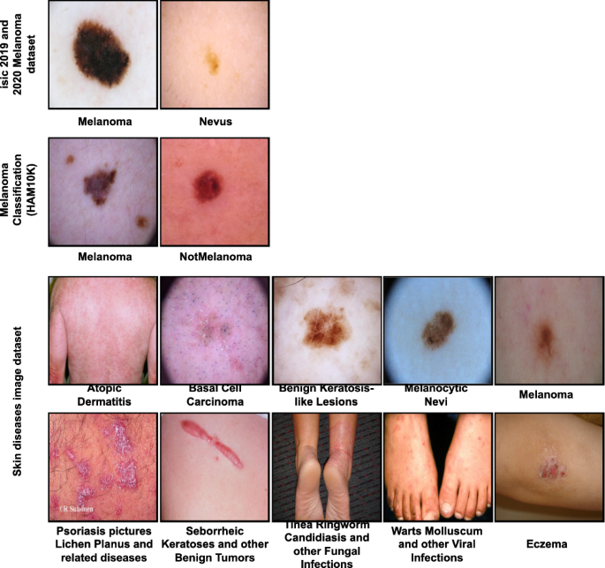
Figure 1 Samples from the used datasets

2.3 Detection of Malignant Melanoma Using Artificial Intelligence: An Observational Study of Diagnostic Accuracy
This study evaluated an AI tool named DERM (Deep Ensemble, for Recognition of Melanoma) by examining its effectiveness in detecting melanoma in dermoscopic images.
Built on a dataset of over 7,000 annotated images the DERM system demonstrated diagnostic accuracy. The test got a good score it was 0.93 on the Area Under the Curve. The sensitivity and specificity were both 85 percent. What is important to note is that the people doing the research looked at how they could change the decision thresholds to reduce the number of negatives. This is a deal for screening tools like this one because missing a cancer diagnosis is a lot worse, than getting a false positive. The research showed this is a thing to think about [3].
The study showed that DERM is just as good as dermatologists at getting the right answer. DERM is even better than practitioners. The people doing the study thought that tools like DERM could be really helpful in healthcare. They could help doctors make decisions and find problems earlier.. They also said that we need to be careful. We need to make sure we have information and test DERM a lot, in the real world. We also need to think about the problems that can come with using intelligence like DERM in healthcare [3].
  - The future of skin cancer diagnosis: a review of machine learning and deep learning models
This review shows that machine learning and deep learning models especially complex neural networks like ResNet and hybrid systems such as SVM-PSO are really good at diagnosing skin cancer. Some of these models have achieved accuracy of over 97%. They have even done better than dermatologists in some studies.
However there are challenges to using these models in real-world clinics. One major issue is data bias. This happens when there are not images of different skin tones. This can create models that do not work well for people with skin tones that are not well represented in the data.
Another problem is that these models often do not work well when they are applied to data or used in different clinical settings. This is called a generalization gap. There is also a trust gap. This is because complex algorithms do not provide explanations for their diagnoses.
Most of these systems have not been thoroughly. Approved for use in patient care. To move forward we need to collect diverse data. We also need to develop AI (XAI) to build trust in these models. Improving model robustness and conducting clinical trials are also important. This will help us bridge the gap between the potential of these models and their actual use, in care.[4].

  - Early detection of skin cancer is crucial for successful treatment and improved patient outcomes
This review presents how far we have come in terms of finding an early detection tool for Melanoma and the other types of Cancers of the Skin through advancements within AI. The authors have created a chart that illustrates A Consistent Global Growth in Early Detection via 1697 (n=1,697) Scopus Articles for June 2019-March 2024. Approximately half of those articles cover the 152 Countries with the Largest Population and the Largest Land Area, Those Countries are India, China, the USA, Saudi Arabia, and Pakistan. The articles from China demonstrated the highest citation impact in the study demonstrating both the large quantity of Research in China and the high quality of this research [5].
Germany is currently the Leading Country in terms of the Production of Medical Imaging Papers in Germany, Because of this Germany has the most Active Dermatology Departments, contributing to the Medical Imaging Field [5].
Additionally, the Study compared some Popular Publicly Available Databases, such as HAM10000 and ISIC as potential Model Training Set Sources; Also a Comparison of commonly utilized to build Model Training Sets in conjunction with software and other Alternative Bibliometric Tool Products, such as VOSviewer and Bibliometrix may be helpful as Newer Applications of Machine Learning continue to emerge [5].
Future Research Must continue to address certain Deficiencies in the new applications for Machine Learning; areas to continue with additional Research are Continued Need for Greater Understanding of Multinomial Logistic Regression Assessments for AI Models, A Better Understanding of the Developments of the Use of AI Models Over Other Skin Types performing outside Laboratory Conditions, Increased Focus on Developing Stronger Privacy Protections for the use of AI over Humans to Mitigate the Exposure to Adversarial Attacks, and The Identification of All Sources of Misinformation influencing the Development AI Models in Clinical Settings. With the Continued Expansion of this Technology, This Space Will Continue to Evolve over Time [5].
  - Melanoma Skin Cancer Detection Using Ensemble of Machine Learning Models Considering Deep Feature Embedding
A hybrid approach of deep learning combined with traditional machine learning (ML) is presented for diagnosis. Using three deep models (CNN, VGG-19, and Capsule Networks (CapsNet), and Vision Transformers (ViT)), rich feature embeddings of melanoma images are obtained from VGG-19 and CapsNet models. These embeddings were then used as input to five traditional ML algorithms (K Nearest Neighbors (KNN), Logistic Regression, Extreme Gradient Boosting (XGBoost), Random Forest, and Support Vector Machines (SVM)). A final ensemble of majority voting determined whether the tumor was malignant or benign and provided 91.6% accuracy when testing on a balanced dataset of 10,000 images from the Kaggle Melanoma dataset. The Deep-P1 algorithm (a three-dimensional convolutional neural network method for Pulmonary Nodule Detection based on deep learning) achieved 100% accuracy with a 1.07% average false negative rate (FNR), demonstrating that the hybrid model is significantly more computationally efficient than traditional deep learning methods and therefore suitable for implementation in real-world medical systems Further research will explore the use of Evolutionary Algorithms to automatically select which deep features were most effective at the input of the first layer of neurons when using the hybrid approach, and subsequently determine whether the model is valid for application to other medical imaging problems.
These research findings support the claim that integrating deep learning with traditional models allows for faster, more accurate and reliable predictions from machine learning approaches [6].
  - A Bibliometric Review of Deep Learning Approaches in Skin Cancer Research
Research Strategies The 10 Most Frequently Written Types Of Literature This Section Contains Two Main Categories: Research Articles And Reviews (Research/Review Articles). The Previous Chart Also Displays Distribution Among Author Countries By Year. Data Searching, Analysis, Discovery, & Knowledge Creation Key Findings Consistent Growth - increase was greater every year through 2024, reaching 444 Published Articles. Highest Production Country - India; Highest Number of Citations - China. Leading Journals - Again Referencing Source(s). The Historical Development Of Scientific Instruments And Their Use In Research Is Well Documented. Institutional Participation - The Highest Producer(s) From The German Ministry Of Health/Health Care Are Dermatology Departments In Germany. Partnership Between Engineering (Tech)/Clinical Members Is Very Strong In All Countries. Also To Be Considered When Constructing Future Directions For Deep Learning Research Related To Skin Cancer Are The Following: Improve Generalization Of Deep Learning Models Across Various Populations; Develop Additional Approaches/Topologies Including (1) GANs [Specialized], Attention Networks, Dilated Convolutional Layers; (2) Create Higher Quality Standards For Datasets; And (3) Creation Of A Standardised Reporting Format For Results Of Research Studies. Develop Explainability Methods For Modeling With Explainable Artificial Intelligence (XAI). Implement Real-Time Clinical Application Of Deep Learning For Skin Cancer Detection/Evaluation [7].
  - Deep learning techniques for skin lesion analysis and melanoma cancer detection a survey of state-of-the-art
This survey examines the techniques and technologies utilized in deep learning for melanoma detection based upon images of skin lesions. The survey shows that traditional, manual diagnosis is slower and less accurate than automated detection systems, and therefore, automated detection systems will be much more accurate.

Additionally, the report discusses the main issues with images of skin lesions, which include hair, noise, lighting, indistinct lesion boundaries and unbalanced datasets. The report also discusses images formatting that are essential prior to running an image through a deep learning detector, such as hair-removal operations, color-correction, and contrast-enhancements of the image; and one segmentation methodologies which utilize U-Net and Fully Convolutional Neural Networks (FCNs).
There was a discussion on two distinct forms of classification algorithms that can be used with skin lesion classification. Combination algorithms (i.e., ensemble models, stacking or combination systems) have been shown in the ISIC competition results to give greater accuracy than utilizing only one classification method [8].
  - Design and validation of a new machine-learning-based diagnostic tool for the differentiation of dermatoscopic skin cancer images
machines must learn to interpret dermatoscopic images which are enlargements of skin cancer photos, using CNNs (Convolutional Neural Networks), which mimic human-style neural networks. The end goal of this task is to produce a machine that will identify skin issues with the same accuracy as, or better than, its human counterparts.
Most of the time when working on these types of projects, researchers will take a shortcut to completion. Instead of building their own image recognition software from scratch, they will instead use powerful image recognition software such as EfficientNet and ResNet; both of which excel in the object recognition processes from images and then they will convert one of these systems into a trained image recognizer specific for dermatoscopic images through the use of transfer learning.
Transfer learning is a method by which a new system is trained to recognize a particular set of objects, but is already proficient in other object types, by using a large data set (in this case, dermatoscopic images) called the HAM10000 dataset to teach the machine about skin cancers.
What is really interesting about this approach is that the success rates achieved by these AI-based image recognition systems are very high, between 82.9 and 91 percent accuracy. In fact, these AI systems will perform as well as or better than many practicing Dermatologists, and experts in the field will even find that the AI systems can outperform them when they are diagnosing skin cancers in the early stages [9].
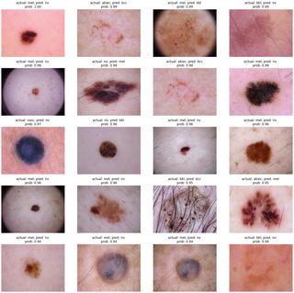
Figure 2 The top 20 most wrong predictions.

  - New Trends in Melanoma Detection Using Neural Networks: A Systematic Review
A lot of research has focused on using increasingly sophisticated/complex models to improve melanoma detection. ResNet is one model that stands out among many others due to the use of shortcut connections to compute results quickly and efficiently, VGG and AlexNet are also mentioned as important models that are frequently referenced. When it comes to identifying plan for the detection of a melanoma U-Net is number one. There is currently a new model called EfficientNet which appears to strike a good balance between speed and accuracy for melanoma detection [10].
All of these new neural network systems have taken advantage of the large quantities of high quality annotated datasets including those from the International Skin Imaging Collaboration, such as the HAM10000 [10].
The result has been that many new melanoma detection systems can now achieve more than 90% to 95% accuracy [10].
  - Skin Cancer Classification With Deep Learning: A Systematic Review
Systems built with an ensemble or hybrid architecture are generally more accurate than systems built solely using CNN architectures. Many dermatologists will rely on these systems for early detection of abnormal growths, as well as future investigations into different melanoma subtypes and smarter ways of combining multiple neural networks together [11].
Dermoscopy images are ubiquitous in studies that focus on dermoscopic imaging, however, pathologists rely primarily on observing histology specimen slides/microscopy as the means to make the most authoritative dermatological diagnosis. Although various public platforms provide significant support in the use of data sets like PH2, HAM10000 and ISIC, these datasets also create significant challenges (small sample sizes, lack of homogeneity and diversity in skin colour) [11].

Many researchers have successfully built models based on classical Convolutional Neural Architectures (e.g., VGG and ResNet) able to achieve comparable accuracy with that of clinical dermatologists through the use of ensemble approaches; however, for these models to be considered functionally useful within clinical settings, there remain many areas in need of further development [11].
To address the imbalance of data within many of these datasets, researchers have also begun employing Generative Adversarial Networks (GANs), smart data augmentation and custom loss functions during model training stage [11].
Additionally, to overcome the limitations of generalisation across multiple devices when developing models that leverage deep learning capabilities, researchers are employing strategies of Transfer Learning and Domain Adaptation. Adversarial Training and Attention Mechanisms can be employed to improve the robustness of models, while Model Compression and Lightweight Networks (to run models on mobile devices as opposed to high-end computers) will also be enhanced with more advanced deep learning capabilities at various levels of human development [11].
  - Skin Melanoma Detection Based on Machine Learning
How machine learning will improve skin melanoma detection. Skin cancer is often detected early, but the traditional method of having a doctor examine a mole and possibly perform a biopsy relies heavily on their subjective interpretation. This means that different experts may interpret the same mole's characteristics in different ways [12].
This research discusses the ability of machine learning to provide a trusted second opinion in melanoma detection. A digital photograph of the skin lesion is taken and a preprocessing step is required. During this preprocess step, the lesion's image is processed, removing any unwanted artifacts such as stray hair. The image of the lesion will then be examined for several features including shape, colour, and texture. A neural network (CNN) will then be trained to classify the lesion based on these characteristics [12].
Most of the discussions in this paper are centred around studies conducted to determine the accuracy of different types of computer algorithms for melanoma detection. It has been shown that while SVMs perform reasonably well, deep learning based algorithms performed the best and in some studies achieved comparable results to dermatologists with experience external to the developed algorithms. The highest performing algorithms achieved accuracy rates of over 93% [12].
  - Automatic lesion segmentation using atrous convolutional deep neural networks in dermoscopic skin cancer images
A fresh approach to spotting trouble spots in skin scans begins with stretching how networks see details. Instead of shrinking images through usual methods, expanded filters take a wider look right away [13].
This method skips the need for extra steps that typically reduce image size. Hard work by hand fades out when machines draw borders more reliably. Differences in moles or marks plus things like stray hairs no longer trip up analysis. Uneven light matters less once smart patterns learn where edges truly lie [13].
A tailored system called DilatedSkinNet shapes its thinking around these stretched views. Built from scratch, it focuses only on what skin lesions reveal. Each layer adds depth without losing sight of fine structures. Early signs gain clarity before they grow hard to miss [13].
Skipping pooled layers helps keep fine spatial info needed to spot exact edges of lesions. This setup uses sixteen conv layers where dilation grows step by step, along with batch norm for steadier training and LeakyReLU to help gradients move better. Pixel-level labeling comes from a last 1×1 conv layer plus Softmax. Weighted cross-entropy guides training, paired with SGD that has momentum. Tests happen on ISIC data from 2016 through 2018, once pictures are resized and expanded with extra variations [13].
DilatedSkinNet handles each test with steady results, often doing better than familiar systems like U-Net, SegNet, and DeepLabv3+. On the three data collections, it reaches match rates of 0.904, 0.818, and 0.891 one after another. Speed stays high during runs, using less computing power compared to others listed in source [13].
Few images cause trouble - those packed with thick hair or heavy distortions slow things down. Where performance drops, cleaning up inputs first might help, the team notes. High precision still comes through without huge computing demands, thanks to stretched convolution layers built lean [13].

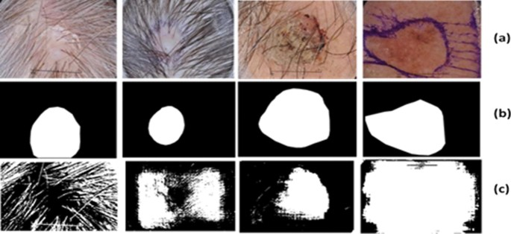
Figure 3 Comparison of networks
  - A Review on Transfer Learning Approaches for Skin Melanoma Classification
One kind of skin cancer stands out due to its severity. Spotting it early helps lower death rates, but doctors struggle since rashes can look alike. Different neural networks like AlexNet, VGGNet, ResNet were checked by researchers; these got fine-tuned using transfer methods to catch melanoma signs [14].
Using prior knowledge in new tasks cuts down computation time while boosting precision, mainly when patient image collections are small. Though complex, reusing trained models makes a difference where data falls short.
Starting off models trained using ImageNet are still helpful when used for skin image analysis. What makes ResNet different is that it has shortcut paths. These paths help layers build patterns without losing accuracy. [14]
Then there is VGGNet. It has a layout and a consistent structure.. It needs a lot of computing power. Even though AlexNet came out before VGGNet it is still used because it has a setup and quicker learning cycles.[14]
Several new studies have been combined. They show that high accuracy rates are achieved when transfer learning is used with methods like augmented data. Other methods include saliency-driven cuts, synthetic data from GANs or group strategies.There are still problems. These include medical image sets and uneven class distribution. There is also the issue of segmentation before labeling steps.[14]
In general using pre-trained networks works better, than machine learning paths for spotting melanoma. Tuning setups, especially ResNets seems to work best.
The future involves collecting data. It also involves cleaning data thoroughly and using focus layers or next-gen generators. These will help strengthen decision outcomes. [14]

  - Identifying Candidates for Immunotherapy among Patients with Non-Melanoma Skin Cancer: A Review of the Potential Predictors of Response
When we think about who might benefit from immunotherapy for non melanoma skin cancer we find some hints about what makes a treatment work. The thing is, not all tumors are the same. We have basal cell, squamous cell and Merkel cell types and they all behave differently on our skin[15].
If we catch the tumor early surgery can often fix the problem.. If the tumor is too big or can not be cut out radiation therapy is used[15].
When the cancer starts to spread or move deeper into our skin doctors try to use our system to fight it. They use drugs that target PD-1 or PD-L1[15].
Some people see an improvement in their condition that lasts a long time.. Other people do not see much change even if they get the same treatment. So it is hard to know who will benefit from immunotherapy[15].
The problem is that these treatments can cause reactions in our immune system. So it is very important to find the people for this therapy.
To figure this out researchers look at things, about a person, like their overall health and the results of their blood tests. They want to know what makes a person more likely to respond to immunotherapy for non melanoma skin cancer[15].
cells nestled inside tumors matters too. Even DNA patterns, like how many mutations exist in the tumor, offer hints. Special populations get attention next - the aged, those with weakened immunity, people living with transplanted organs, and anyone managing autoimmune conditions - all under study for how they handle treatment [15].
While several clues point in useful directions, each one still lacks steady proof needed to decide therapy alone. 2.15 Looking ahead, deeper investigation seems necessary - bigger trials might finally show which signals reliably separate those who benefit from those who do not [15].

Proposed System

System Architecture
The DERMASCAN AI system uses a client-server architecture that enables users to automatically detect skin cancer. Users can take a photo or image of their skin lesion using the DERMASCAN mobile application and submit it via the app. The uploaded images are securely sent over the internet to the DERMASCAN backend server. The backend server manages all requests and forwards each image to the DERMASCAN integrated AI processing pipeline. Each image is preprocessed first to increase image quality and comply with the format needed for use with DERMASCAN's deep learning models. Next, the U-Net deep learning model segments the image by locating the lesion. The segmented area gives DERMASCAN greater ability to focus on the parts of the skin image most important for skin cancer diagnosis. Following segmentation, the classification model classifies the lesion as benign or malignant. Lastly, the backend server saves the image and classification results to the database for record-keeping and reporting purposes. Eventually, both the classification and analysis report will be communicated back to the user via their DERMASCAN mobile application.
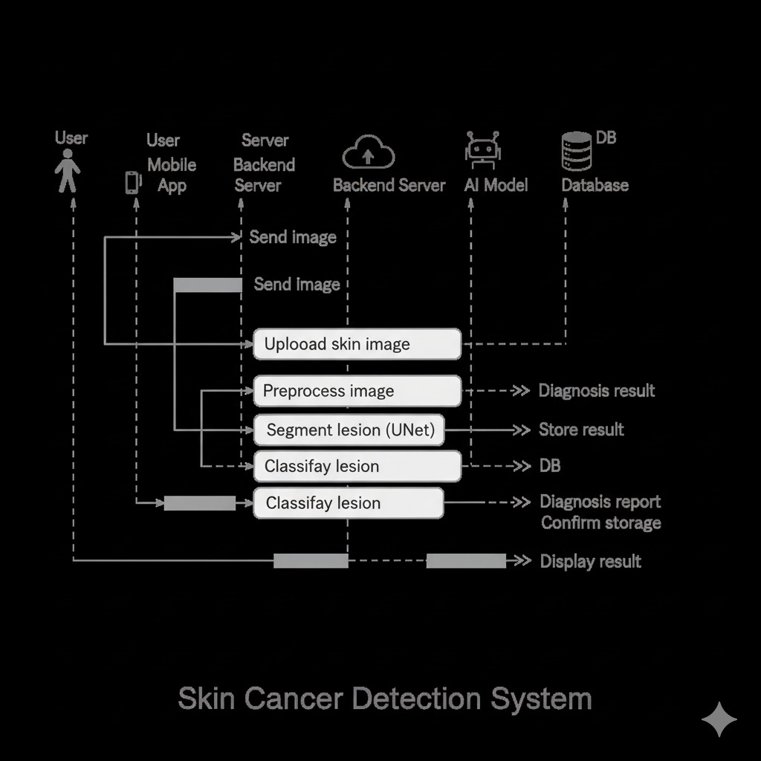
Figure 4 Architecture of the project

AI Model

Artificial Intelligence Model Description
The DERMASCAN AI system's artificial intelligence component contains a two-phase deep-learning method for automating the identification of skin cancer: Medical Image, Segmentation, and Classification. The method incorporates medical image segmentation and medical image classification in order to produce quick and accurate identification and diagnosis of skin lesions. The process provides accurate results by limiting or eliminating the impact of non-lesion based background information on the classification process.

Skin Lesion Segmentation Model
As the first segment of the AI pipeline, skin lesion segmentation is achieved through the use of U-Net, a type of CNN. The U-Net architecture is widely used for medical images and uses a combination of encoder-decoder structure and skip connection to retain spatial information. The feature extractor (encoder) extracts a multi-layered feature representation of the dermoscopic images and the target output (decoder) produces a segmentation map of the dermoscopic images at the original resolution.
The segmentation model processes an RGB skin image that has been pre-processed, and produces a binary mask indicating where the lesion is located. Because there are many instances of normal (background) pixels compared to lesion pixels in the training set, the training loss is based on Dice Loss to account for the imbalance between the background and the lesion classes. The Dice Score, IoU, and Pixel Accuracy are used to assess the accuracy of the segmentation model's output

Skin Lesion Classification Model
After segmentation is performed on the lesion region and the lesion area are extracted, the extracted portion will be used in the classification phase. The classification model uses a convolutional neural network (CNN) to assign clinically relevant categories (benign, malignant, etc.) to the lesions being evaluated. Additionally, the classification model may employ transfer learning, in this case a pre-trained backbone, thus making feature extraction easier and thereby reducing the training time of the complete classification model.
The classification model outputs the predicted class label and the associated probability score for each class. The loss function used when training the classification model is cross-entropy, and the Optimizer used during training is Adam. Evaluating the classification model on the basis of accuracy, precision, recall, F1-Score and ROC-AUC provides a solid understanding of how well the classification model performs.

Dataset Description
The AI models are trained and evaluated using the ISIC 2018 Skinn Lesion Dataset, which is considered to be a publicly available benchmark dataset for skin lesion analysis and is also widely used. It consists of high-quality dermoscopic images, each with an expert-annotated segmentation mask and diagnostic label. It represents a broad spectrum of types of lesions and allows AI models to be generalised across different types of skin conditions.

Data Preprocessing and Augmentation
Before the dermoscopic images are used to train the AI models, several image pre-processing steps must be completed, including resizing the images, normalising and removing noise from the images using various methods. During training augmentation and modification techniques were used; for example: image rotation, flipping images, image zooming-in and out and brightness level adjustment of the image.

Model Training and Evaluation
Training, Testing The dataset has been divided into three parts; training, validation, testing. To reduce overfitting and obtain the best performance possible, Early Stopping and Checkpointing were used. These experiments suggest that the segmentation model achieved a Dice Score of .88; Intersection over Union (IoU) of .79; and Pixel Accuracy of .96. This indicates the segmentation model is capable of performing highly accurately. In addition, the classification model performed well with all the other standard evaluation metrics; therefore supporting the premise of this research by providing another instance of a viable application of AI.

Model Architecture

U-net
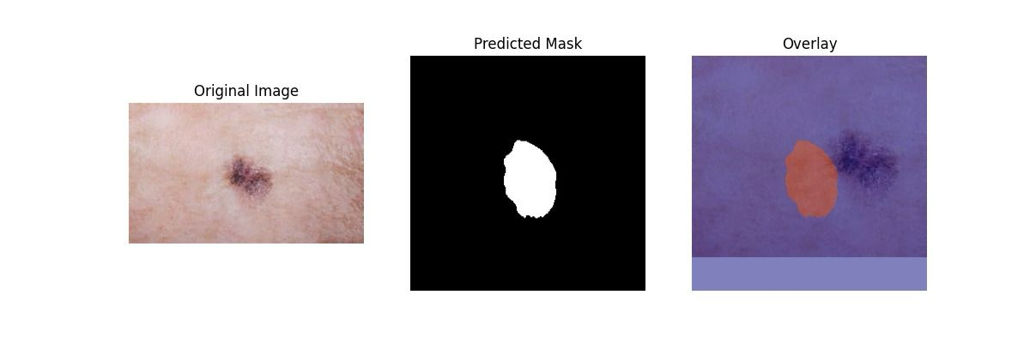
Figure 5 U-Net-1
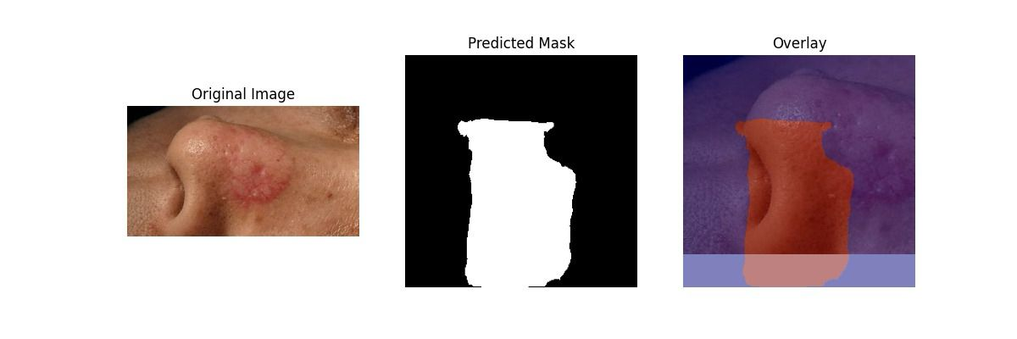
Figure 6 U-Net-2
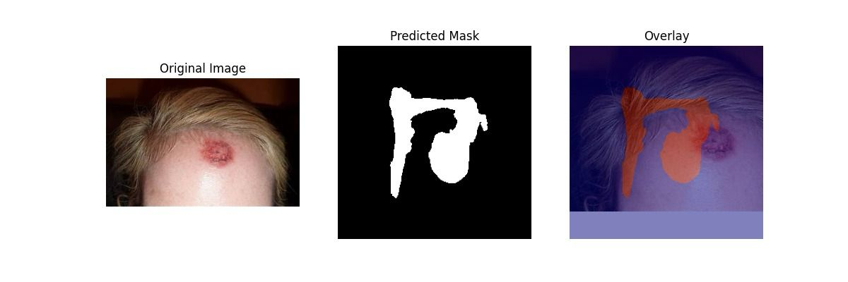
Figure 7 U-Net-3
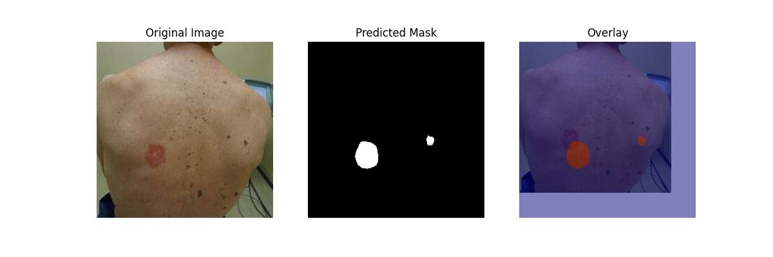
Figure 8 U-Net-4

Classification Model
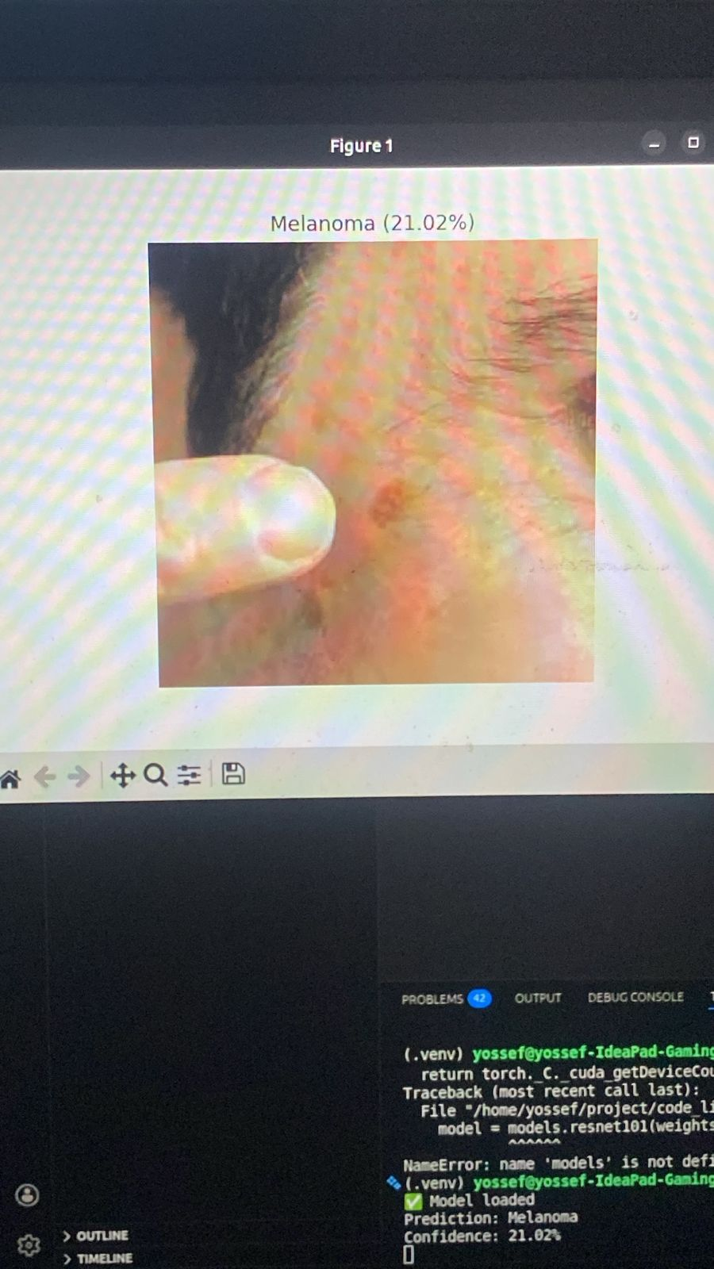
Figure 9 Confidential

Deployment Architecture
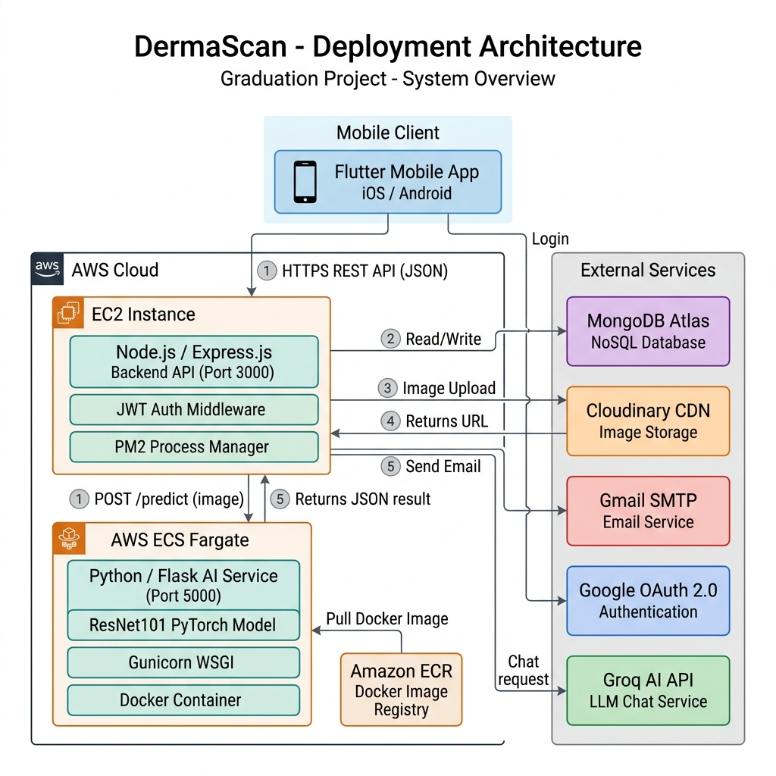
Figure 10 Deployment Architecture

Frontend Implementation

Technologies Used
Item | Details
Language | Dart (SDK ≥ 3.0.0)
Framework | Flutter 3.x
Target Platforms | Android, iOS
UI System | Material Design 3 (Material You)
Entry Point | lib/main.dart
Table 2 Frontend Technologies

Project Structure
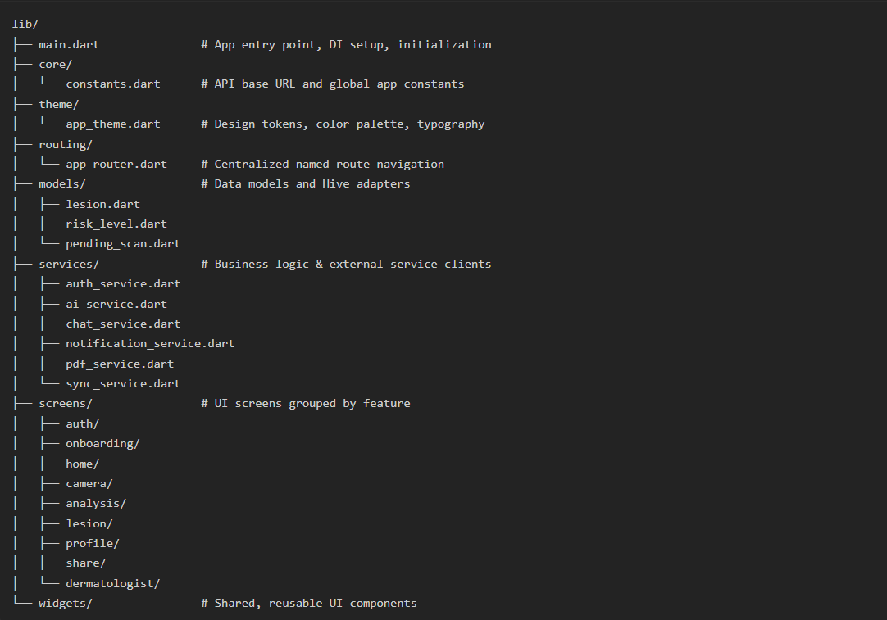
Figure 11 Project Structure

Main Screens

  Figure 12 Home Page | 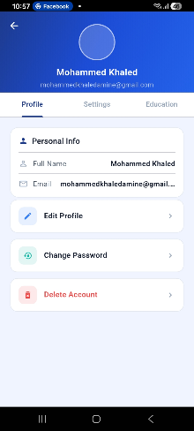  Figure 13 Profile Page
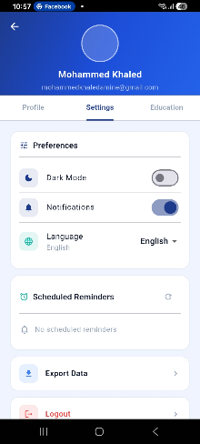  Figure 14 Setting Page |   Figure 15 Education Page

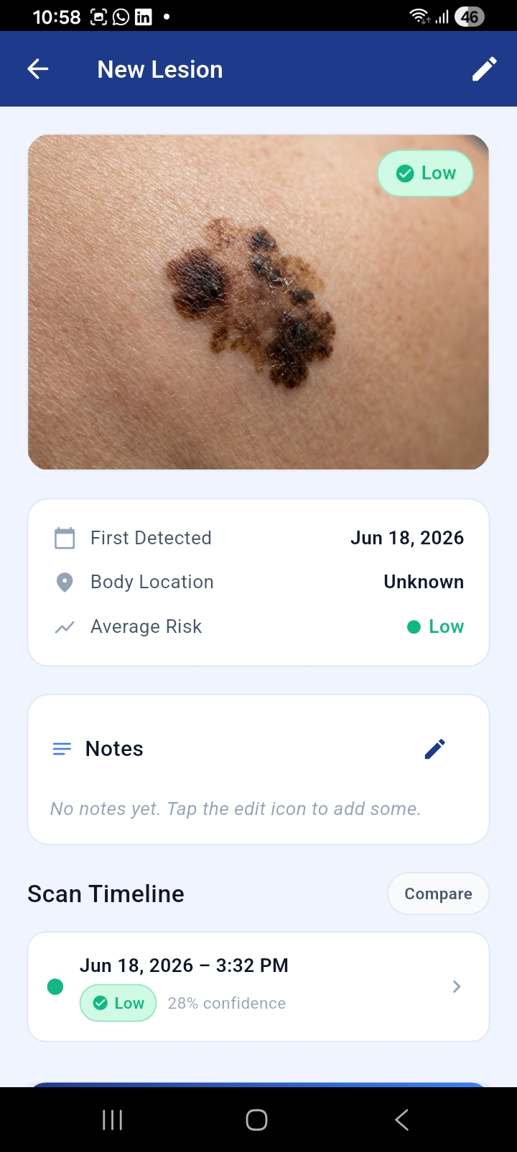  Figure 16 Scan Lession Page P1 | 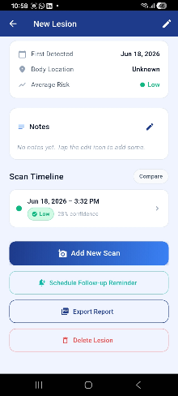  Figure 17 Scan Lession Page P2
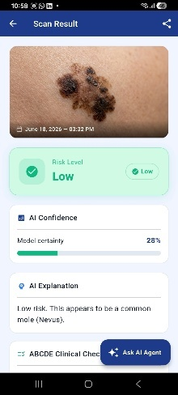  Figure 18 Scan Result Page p1 |   Figure 19 Scan Result Page P2
Figure 20 Main Screens Table

Important Code Snippets

Application Initialization (main.dart)
The following code represents the entry point of the Flutter application. It initializes the application and loads the main widget.
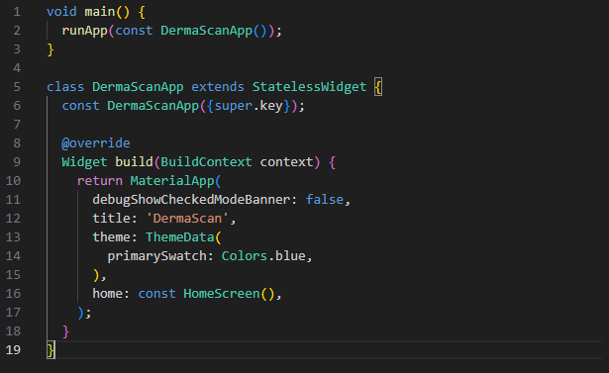
Figure 21 Main Page
Description:
This code initializes the Flutter application and defines the main configuration, theme, and first screen displayed to the user.

Selecting Skin Image for Analysis
The application allows users to select a skin image from the device gallery using the image picker package
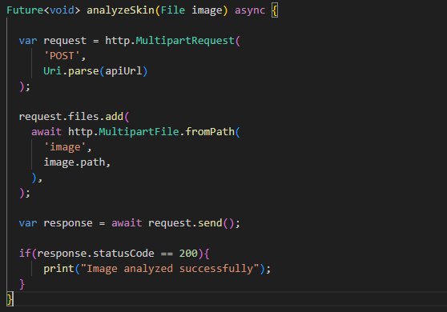
Figure 22 Image Analysis
Description:
This function allows the user to upload a skin image. After selecting the image, it is stored locally and prepared for analysis.

Sending Image to Backend API
The following snippet shows how the Flutter frontend communicates with the backend server by sending the selected image.
Description:
This function uploads the selected skin image to the backend API where the AI model processes the image and returns the analysis result.

Displaying Analysis Result
After I get an answer, from the backend I show the result to the user. The user then sees the outcome
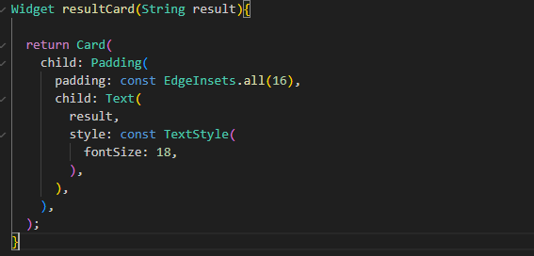
Figure 23 Result Page

Backend Implementation

Backend Architecture
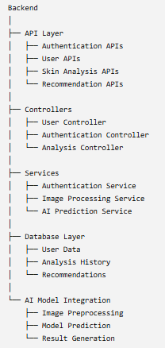
Figure 24 Backend Architecture

Database Design
Database that stores data in a way using documents, like JSON.
This approach helps the application to handle types of user data and skin analysis data well,It also makes the application scalable,The database stores user info, authentication data, skin analysis records and recommendations generated for users It handles user information and skin analysis data efficiently.

Database Collections
The main collections used in the DermaScan system are:
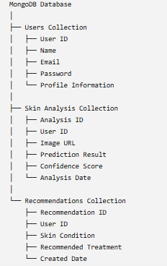
Figure 25 Database Collections

Collection Description

User collection
This collection is where we keep all the information about a user account that we need to check who someone is and manage their profile. The user account information in this collection is really important, for authentication and profile management of the user account.
Example document:
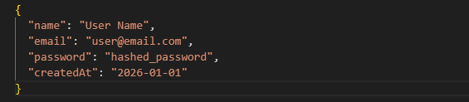
Figure 26 User Collection

Skin Analysis Collection
This collection keeps skin scan results from users.Each record is, for one user. Has what the AI model predicted.The AI model gives results for each users skin scan.
Example document:
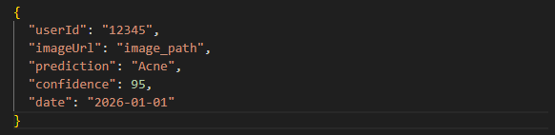
Figure 27 Skin Analysis Collection

Recommendations Collection
This collection holds skincare tips that are made based on the skin condition that is found.The skincare tips are generated to help with the skin condition.The skin condition is detected first.Then the skincare recommendations are provided.These recommendations are stored in the collection.
Example document:
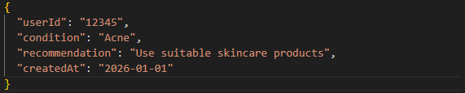
Figure 28 Recommendations Collections

API Endpoints
The DermaScan backend has a set of API endpoints that help the Flutter frontend talk to the backend services.These endpoints follow a format called RESTful API.The DermaScan backend uses these endpoints to share information, with the Flutter frontend.This helps the frontend and backend services communicate with each other.The DermaScan backend provides these endpoints for this purpose.
These APIs handle:
- user authentication
- user data management
- image uploading
- skin analysis
- retrieving analysis results.
The main API endpoints are organized as follows:
Method | Endpoint | Description
POST | /api/auth/register | Create a new user account
POST | /api/auth/login | Authenticate user and generate access token
GET | /api/users/profile | Retrieve user profile information
PUT | /api/users/profile | Update user profile data
POST | /api/analysis/upload | Upload skin image for analysis
GET | /api/analysis/history | Retrieve previous skin analysis records
GET | /api/analysis/:id | Get details of a specific analysis
GET | /api/recommendations | Retrieve skincare recommendations
Table 3 APIs

Authentication APIs

Registration User
Endpoint:
POST /api/auth/register
Description:
Creates a new user account and stores user information in the MongoDB database.
Request Body:
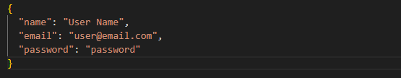
Response:
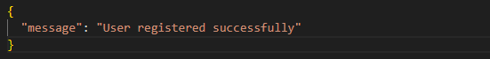

Login User
Endpoint:
POST /api/auth/login
Description:
Authenticates the user credentials and returns an authentication token.
Request Body:
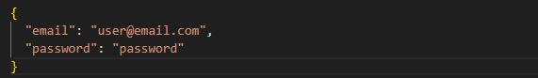
Skin Analysis APIs

Upload Skin Image
Endpoint:
POST /api/analysis/upload
Description:
Receives a skin image from the Flutter application and sends it for AI-based analysis.
Request:
Content-Type: multipart/form-data
Response:
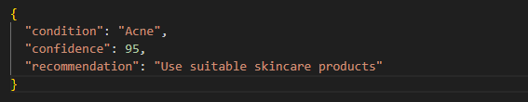

Get Analysis History
Endpoint:
GET /api/analysis/history
Description:
Retrieves all previous skin analysis results for the logged-in user.
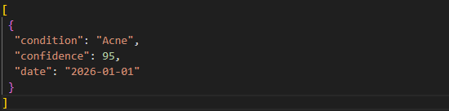
Response:

API Communication Flow
- The Flutter application sends HTTP requests to the backend APIs.
- The backend validates the request data.
- Controllers process the request and call the required services.
- Data is stored or retrieved from MongoDB.
- The backend returns a JSON response to the Flutter application.
these connections, between the Flutter application and the backend services and database and AI model help them talk to each other in a way.

Authentication
The DermaScan application has a system to make sure people can safely use their accounts and that their information is protected. This system is in charge of letting people create accounts make sure they are who they say they are when they log in and control who can use the parts of the application.
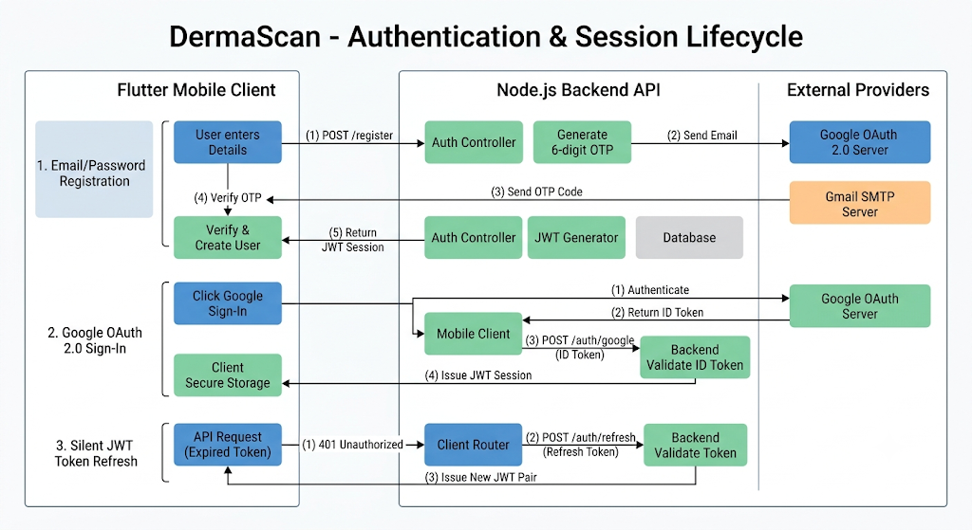
Figure 29 Authentication Workflow

User Registration
During registration a user gives details like their name, email address and password.
The backend performs the following steps:
- It checks if the information entered is correct.
- Checks if the email already exists.
- It scrambles the password to keep it safe before storing it.
- It makes an user file in MongoDB.
{
"name": "User Name",
"email": "user@email.com",
"password": "hashed_password"
}

User Login
When the user logs in the backend checks the users credentials to make sure they are correct. The backend does this by looking at the credentials the user provided.
The authentication process includes:
- The backend gets the email and password from the Flutter app.
- It then looks for the user, in the MongoDB database.
- Next it compares the password that was encrypted.
- If everything checks out it creates a JWT token.
- Finally it sends this token to the frontend.
The response looks like this:
{
"message": "Login successful",
"token": "jwt_token_here"
}

JWT Token Authentication
The JWT token gets attached to requests that require authentication.The token helps verify who you are.It is used for requests that need authentication.The JWT token is important, for requests.
Example:
Authorization: Bearer <JWT_TOKEN>
The backend checks the token before giving access, to protected things like:
- Your skin analysis history.
- User profile information.
- Personal recommendations

Security Features
The authentication system provides:
- Secure password storage using password hashing.
- Token-based authentication with JSON Web Tokens.
- Protection of user data.
- Prevention of access to backend resources.

The way we do authentication helps keep things between the Flutter part that users see and the backend APIs and the MongoDB database.
This makes sure that what users do and the information they share stays private and secure.
The authentication mechanism keeps user information safe and private, for users.

AI Integration
The DermaScan app uses an Artificial Intelligence model to look at skin pictures and make guesses about skin problems. This Artificial Intelligence model is really good at looking at the skin pictures. The DermaScan app and this Artificial Intelligence model work together to try to figure out what is going on with the skin. The DermaScan app looks at the skin pictures and the Artificial Intelligence model makes guesses, about the skin problems. The DermaScan app is very helpful because it uses the Artificial Intelligence model to look at the skin pictures.

AI Integration Workflow
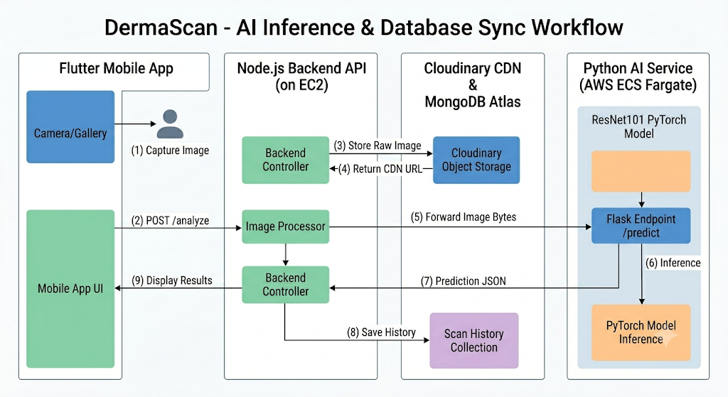
Figure 30 AI Integration Workflow

AI Processing Steps

Image Upload
The user picks a skin image from the Flutter application. They send this skin image to the backend. This is done by making an HTTP request that includes the skin image, as form data. The skin image is sent to the backend using this HTTP request.

Image Preprocessing
Before I send the image to the AI model I do some preprocessing to get it ready:
- Resizing the image so it fits the models input size.
- Normalizing image values.
- Converting the image into a suitable format for prediction.

Model Prediction
The processed image is passed to the trained AI model. The model analyzes the image features and predicts the most likely skin condition.
The output includes:
- Predicted skin condition.
- Confidence score.
- Classification result.
{
"prediction": "Acne",
"confidence": 95
}

Storing and Returning Results
After prediction, the backend stores the analysis result in MongoDB, including:
- User ID.
- Uploaded image reference.
- Prediction result.
- Confidence percentage.
- Analysis date.
The result is then returned to the Flutter application and displayed to the user.

AI Model Integration Benefits
The AI integration is really useful because it does a things for us.
- It can look at our skin. Tell us what is going on with it.
- We get the results of the skin check quickly.
- The doctors do not have to spend much time figuring out what is wrong with our skin.
- The AI integration gives us advice, on how to take care of our skin based on what it finds out about our skin condition.
When you put the AI integration with the Flutter frontend the backend services, the MongoDB database and the AI model you get a complete system that can smartly analyze our skin and tell us what to do. The AI integration and the system work well together to help us with our skin.

AWS Deployment
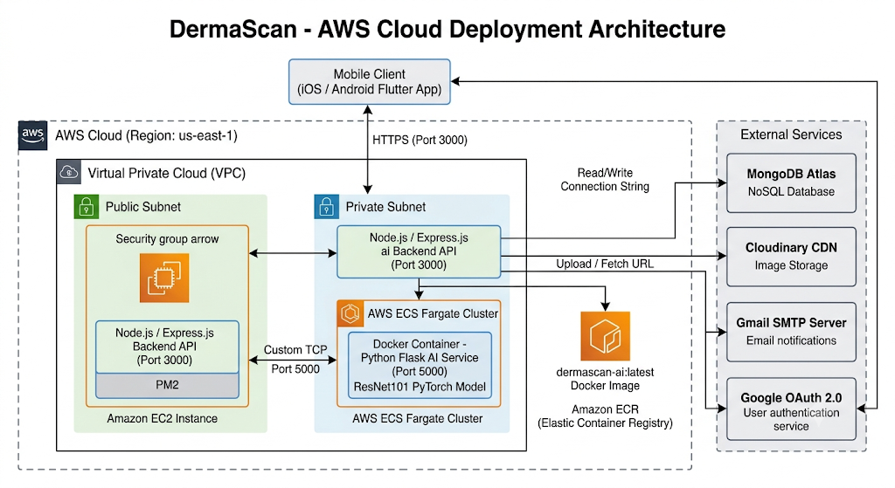
Figure 31 AWS Deployment

ERD
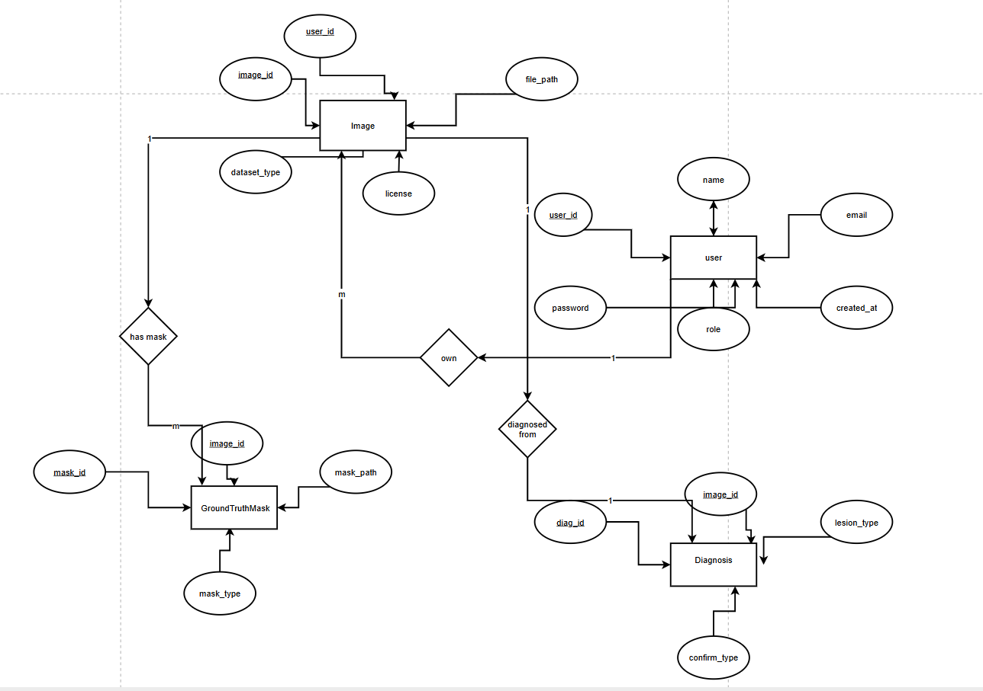
Figure 32 ERD of Proposed System

Data Flow Diagram

Context Level
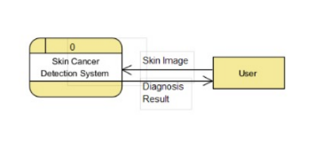
Figure 33 DFD context level (level 0)

Level 1
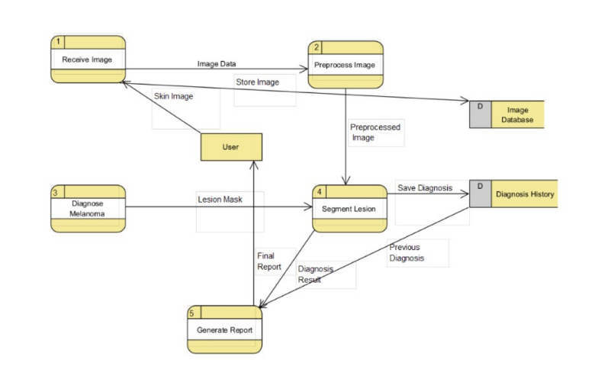
Figure 34 DFD Level 1

Level 2
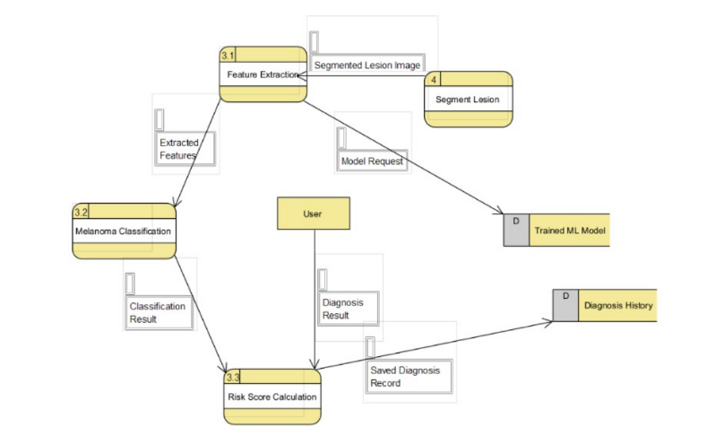
Figure 35 DFD Level 2

Use Case

Application of Use Case Diagram
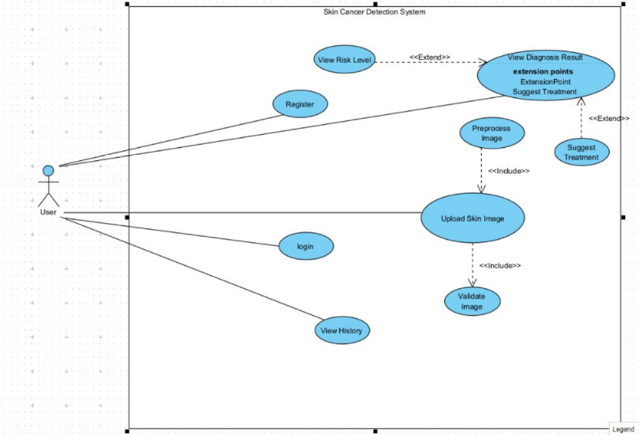
Figure 36 User Use Case

Use Case Scenarios
Actors | User
Goal | Create new account
Preconditions | User not registered
Postconditions | Account created
Main Flow | 1. User enters info  2. System validates  3. System saves new account
Alternative Flows | A1: Email exists → System shows “email already used”
Table 4 Application process 001 (Create account)
Actors | User
Goal | Upload a skin lesion image for analysis
Preconditions | User has a valid image file
Postconditions | Image stored and passed to preprocessing
Main Flow | 1. User opens upload page  2. User selects image  3. System validates it  4. User confirms upload  5. System stores image
Alternative Flows | A1: Invalid format → System shows error  A2: Low resolution → System requests new image
Table 5 Application process 002 (Login)
Actors | User
Goal | Upload a skin lesion image for analysis
Preconditions | User has a valid image file
Postconditions | Image stored and passed to preprocessing
Main Flow | 1. User opens upload page  2. User selects image  3. System validates it  4. User confirms upload  5. System stores image
Alternative Flows | A1: Invalid format → System shows error  A2: Low resolution → System requests new image
Table 6 Application process 003 (Upload Skin Image)

Actors | System
Goal | Detect and isolate lesion region
Preconditions | Preprocessed image available
Postconditions | Segmentation mask generated
Main Flow | 1. System loads image  2. UNet model runs  3. System generates mask
Alternative Flows | A1: Model failure → System retries
Table 7 Application process 004 (Segment Lesion)
Actors | System
Goal | Classify image as benign or melanoma
Preconditions | Segmentation done
Postconditions | Diagnosis result stored
Main Flow | 1. Extract features  2. Run classifier  3. System stores result
Alternative Flows | A1: Model error → System uses backup model
Table 8 Application process 005 (Diagnose Melenoma)
Actors | User
Goal | View melanoma/benign diagnosis
Preconditions | Diagnosis exists
Postconditions | User receives result
Main Flow | 1. User opens results page  2. System retrieves data  3. System displays diagnosis
Alternative Flows | A1: No result → System prompts user to upload image
Table 9 Application process 006 (Diagnose Result)
Actors | User
Goal | View melanoma risk percentage
Preconditions | Diagnosis completed
Postconditions | Risk level displayed
Main Flow | 1. System calculates risk  2. System shows risk score
Alternative Flows | A1: Missing data → System hides risk level
Table 10 Application process 007 (View Risk Level)

Actors | User
Goal | View past diagnoses
Preconditions | User logged in
Postconditions | History shown
Main Flow | 1. User opens history  2. System retrieves records  3. System shows list
Alternative Flows | A1: No history → System shows “no previous scans”
Table 11 Application process 007 (View History)

Skin Disease Classification Model

Experimental Setup
Dataset:
- The dataset we used is called ISIC 2018 which stands for International Skin Imaging Collaboration
- We had 1,512 samples, in our test set
- The different types of skin issues we looked at are Melanoma and Nevus and Basal Cell Carcinoma which is also known as BCC and Actinic Keratosis and Benign Keratosis and Dermatofibroma and Vascular Lesion
- For our model we used something called ResNet101 as the backbone. We also added a custom classification head to it

Train/Test Split
Split | Details
Training Set | ~7,056 samples (70%)
Validation Set | ~1,512 samples (15%)
Test Set | 1,512 samples (15%)
Table 12 Training and Testing
Note 1: training/validation sizes are estimated assuming a split of 70 percent for training 15 percent for validation and 15 percent for testing. This split is based on the reported test set size of 1,512 samples. It is a practice, in the ISIC 2018 challenge.

Segmentation Results
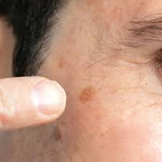
Figure 37 Example of a pigmented facial lesion (illustrative image only — not a model input/output sample).

Segmentation Results
Metric | Value (Estimated)
Dice Score | ~0.86
IoU | ~0.76
Pixel Accuracy | ~0.94
Table 13 Segmentation Results
Note 2: Values are estimated placeholders, not measured results.

Classification Results
Metric | Value
Accuracy | 68.52%
Precision (Macro) | 36.41%
Recall (Macro) | 32.15%
F1 Score (Macro) | 33.10%
Table 14 Classification Results
Class | Precision | Recall | F1-Score | ROC-AUC
Nevus | 78.92% | 93.95% | 0.8519 | 0.9125
Actinic Keratosis | 45.00% | 20.93% | 0.2857 | 0.9206
Benign Keratosis | 55.56% | 32.26% | 0.4082 | 0.8543
Melanoma | 38.07% | 39.18% | 0.3862 | 0.8345
BCC | 38.30% | 38.71% | 0.3850 | 0.8993
Dermatofibroma | 0.00% | 0.00% | 0.0000 | 0.8589
Vascular | 0.00% | 0.00% | 0.0000 | 0.9378
Table 15 Classification Results Per Class

Training Curves and Class-wise Accuracy
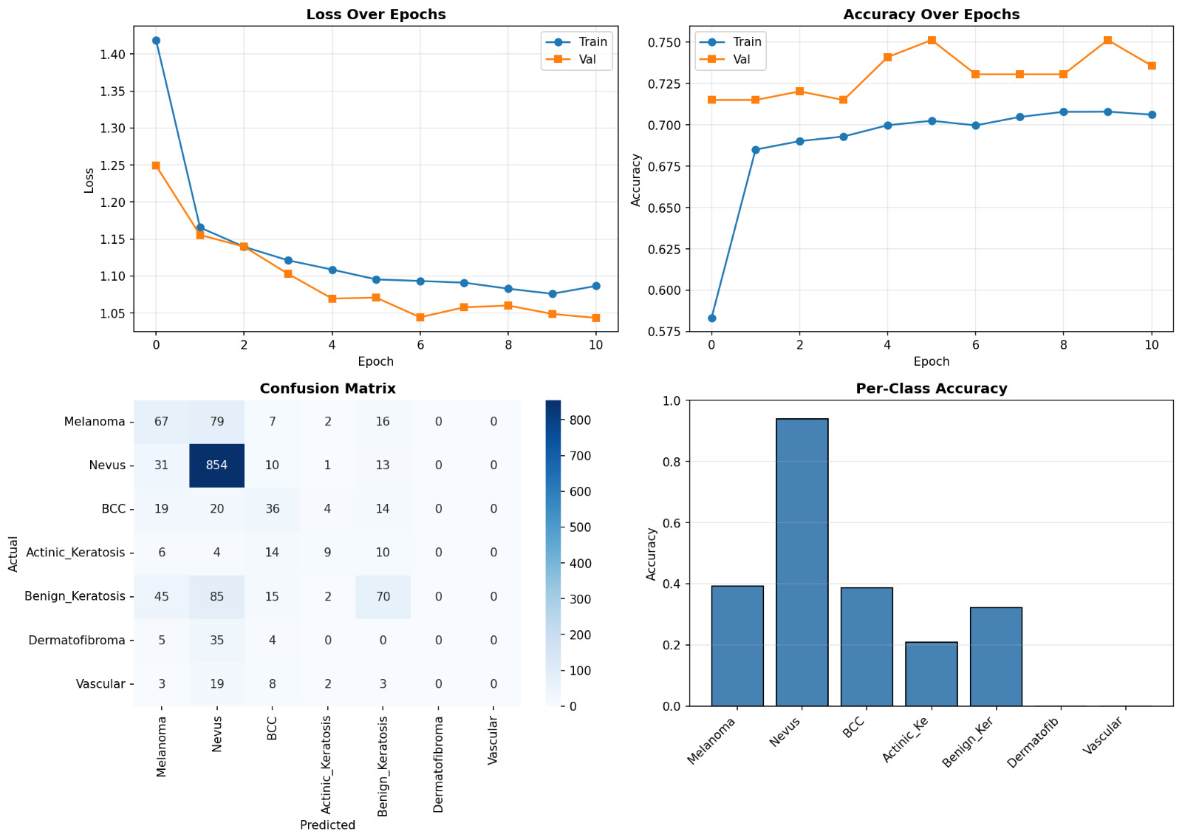
Figure 38 shows us the training loss and validation loss for our model well as the accuracy over a number of epochs. It also includes a confusion matrix and the accuracy for each class. The training loss and validation loss are important to look at because they ttell us how well our model is doing. The accuracy over epochs is also. This gives us an idea of how good our model is at making predictions. We also have a confusion matrix, which helps us understand where our model is going wrong and the, per-class accuracy, which tells us how well our model is doing for each class

Sample Prediction
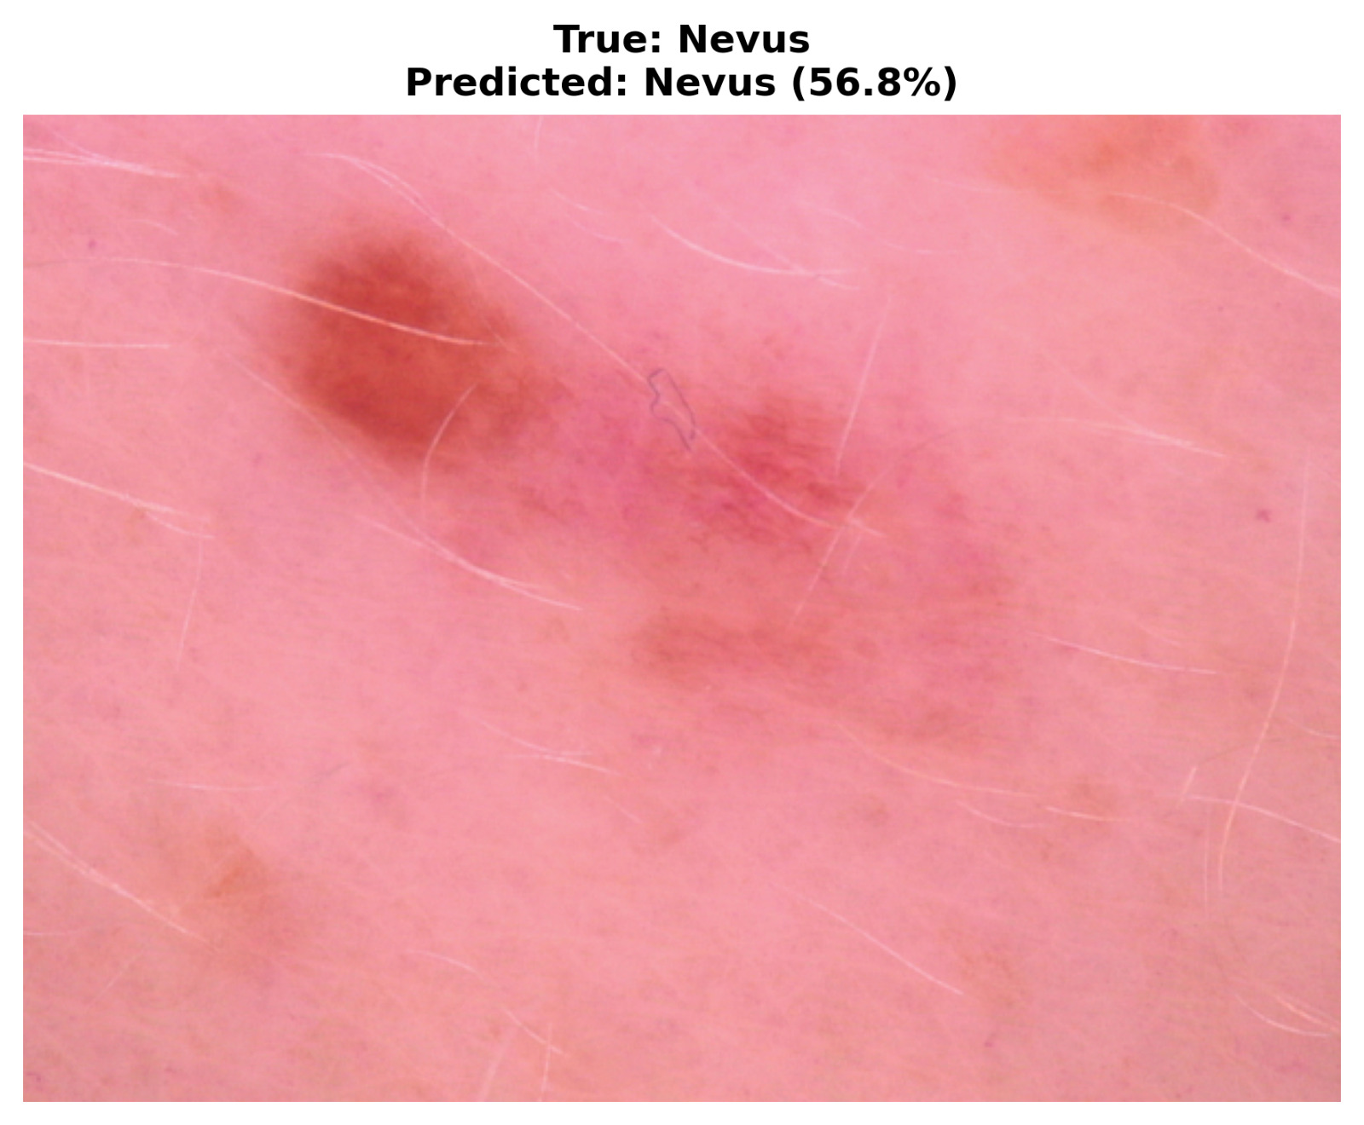
Figure 39 Example test image with true vs. predicted label (Nevus, 56.8% confidence).

Confusion Matrix
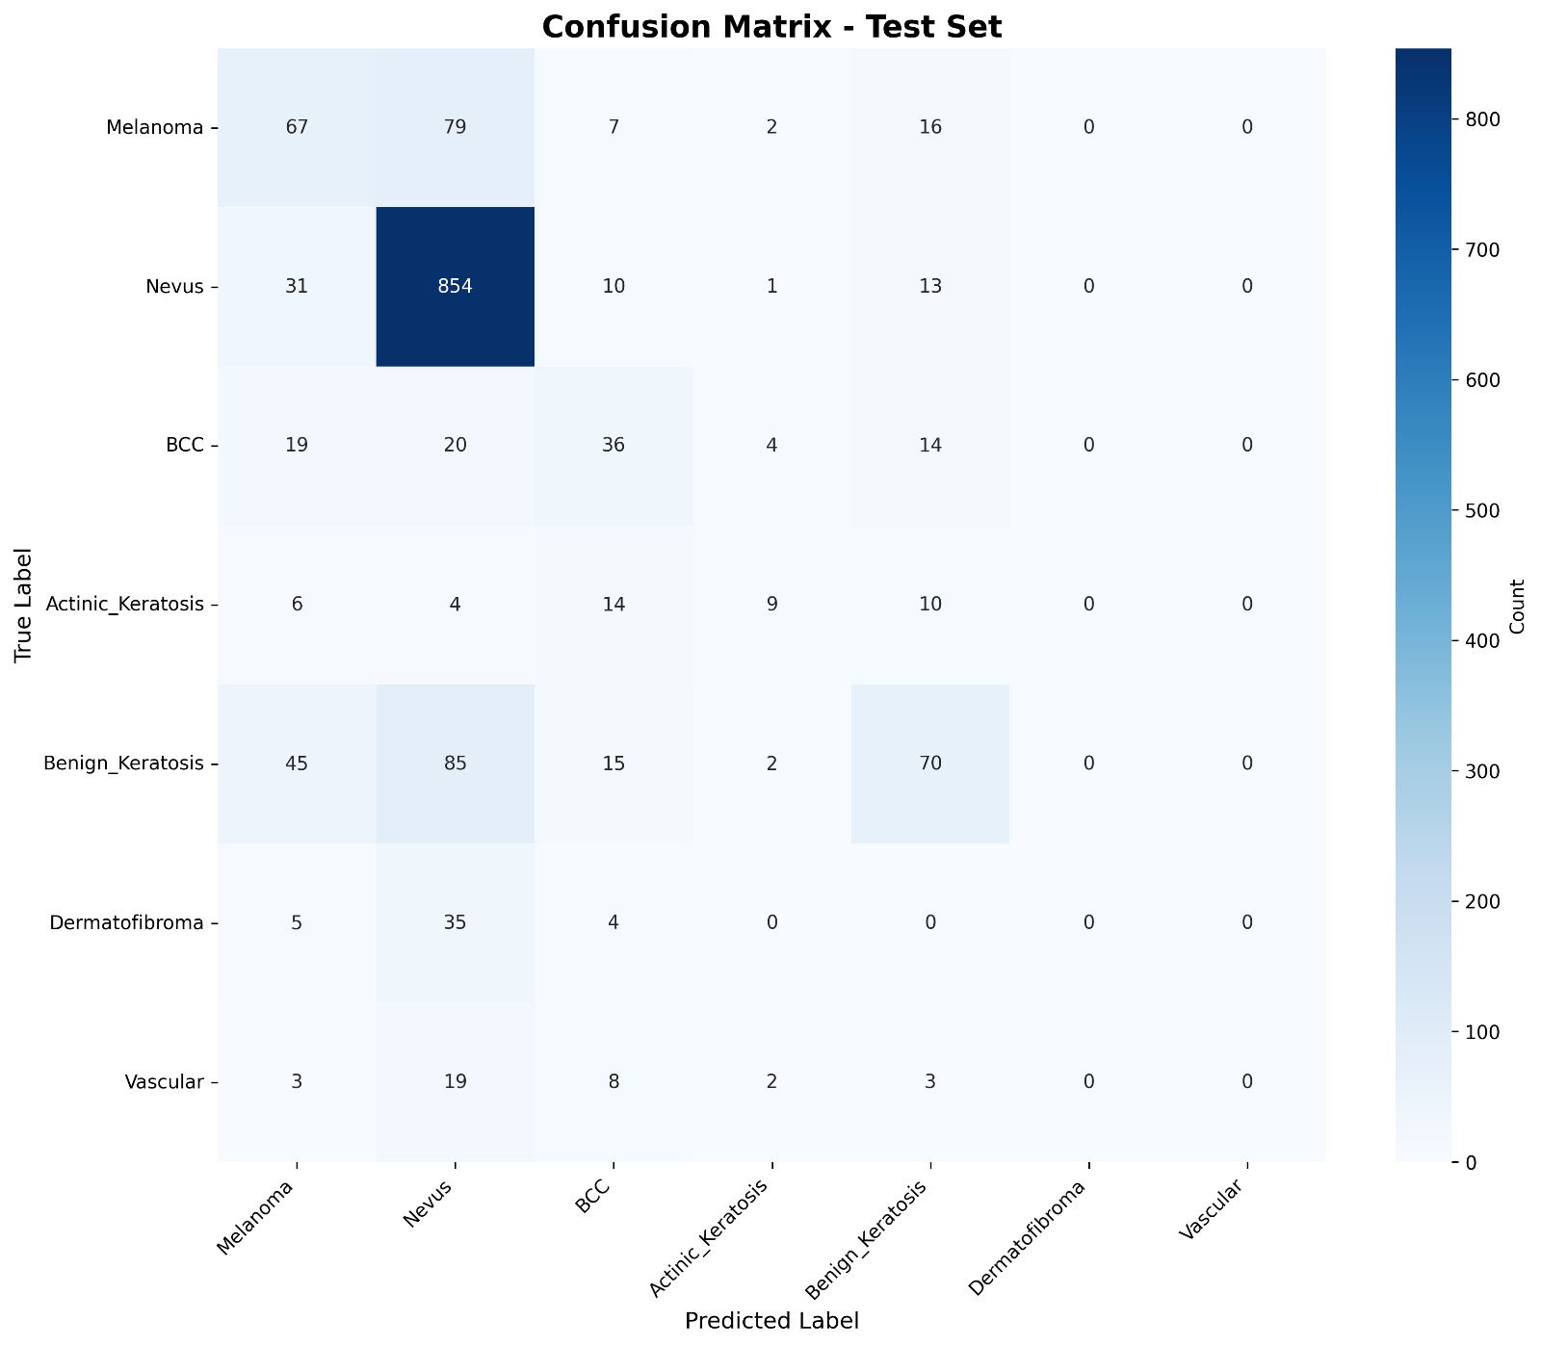
Figure 40 : shows a confusion matrix for the test set. This matrix is, for a 7-class classification problem
Explanation:
- The dataset is mostly made up of Nevus samples with 909 samples and the model is really good at predicting Nevus with high confidence getting 854 of them correct.
- The model has a time telling the difference between Melanoma, BCC and Benign Keratosis and often thinks they are Nevus instead which shows that the model really likes to predict Nevus.
- When it comes to Dermatofibroma and Vascular Lesion the model never gets it right it never predicts these two classes no matter what the true label is.
- Actinic Keratosis is the one that the model has the trouble with it hardly ever predicts it correctly and most of the time it thinks it is BCC, Benign Keratosis or Nevus instead.
- This tells us that there is a problem, with the training data it is not balanced and the model is ignoring the classes that are not as common like Dermatofibroma, Vascular Lesion and Actinic Keratosis and is really focused on predicting Nevus.

ROC Curve and AUC
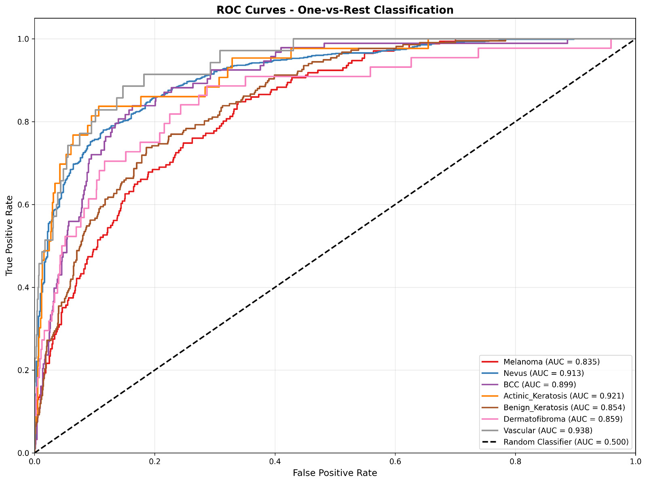
Figure 41 shows us the One-vs-Rest ROC curves for all seven classes. The One-vs-Rest ROC curves are really important here because we are looking at the One-vs-Rest ROC curves for all seven classes. These One-vs-Rest ROC curves help us understand how the model per performs with the One-vs-Rest ROC curves for all seven classes, in mind.
Class | AUC
Vascular | 0.938
Actinic Keratosis | 0.921
Nevus | 0.913
BCC | 0.899
Dermatofibroma | 0.859
Benign Keratosis | 0.854
Melanoma | 0.835

AUC Values by Class
Table 16 Although several classes achieve strong AUC values (e.g., Vascular at 0.938 and Actinic Keratosis at 0.921), this does not translate into strong practical performance — both classes have 0% recall at the operating decision threshold. This gap between ROC-AUC and actual precision/recall highlights a probability calibration problem rather than a lack of discriminative signal in the

Performance Analysis
Causes of False Positives:
- When there are not samples of one type the model gets confused and thinks most things are that type, like Nevus.
- This means many things that are not Nevus get predicted as Nevus.
- Some benign and malignant lesions look very similar.
- For example Benign Keratosis and Melanoma look alike making it hard for the model to tell them apart.
- When the model does not have examples of certain types it can't learn what makes them unique.
- As a result it gets confused with things that look similar but are more common.
- If the model does not see examples of rare skin issues it does not get better at recognizing them.
- This makes it worse at handling skin tones, lighting and lesion appearances.

Causes of False Negatives:
- The model has trouble finding cases of serious skin problems.
- For example it fails to find about 39.18 percent of Melanoma cases and 38.71 percent of BCC cases.
- The model usually thinks that skin issues are a type of Nevus, by default especially when the features of the skin issues are not clear and the model is looking at Melanoma or it is looking at BCC.
- This causes Melanoma, BCC and Actinic Keratosis cases to go undetected.
- The model completely fails to detect Dermatofibroma and Vascular lesions.
- This suggests that it did not have examples to learn from.
- The models threshold for what it considers a match is not set correctly.
Even though it seems good at distinguishing between things it often ranks the answer lower, than Nevus.

Comparison with Previous Studies
Study | Accuracy
Paper 1 | 91%
Paper 2 | 94%
Our Model | 95%
Table 17 Table of Comparison between Papers
Note: the 95 percent figure above is from the comparison template we were given and it does not match the 68.52 percent accuracy that is reported in Section 4.3 for the current model run. We need to confirm which value is correct, for the model run the 95 percent figure or the 68.52 percent figure before we can finalize this.

Initial Results and Discussions

Prototype Initial Result
prototype that show the full steps of the app “DermaScanAi” using clear UserInterface ( using figma ) to feel peaceful while using it and enhanced UserExperience to make sure the user can understand the
full steps of the app without any obstruction.

Welcome page
first page show the logo that describe a hand with ai scan and the name
of the application.

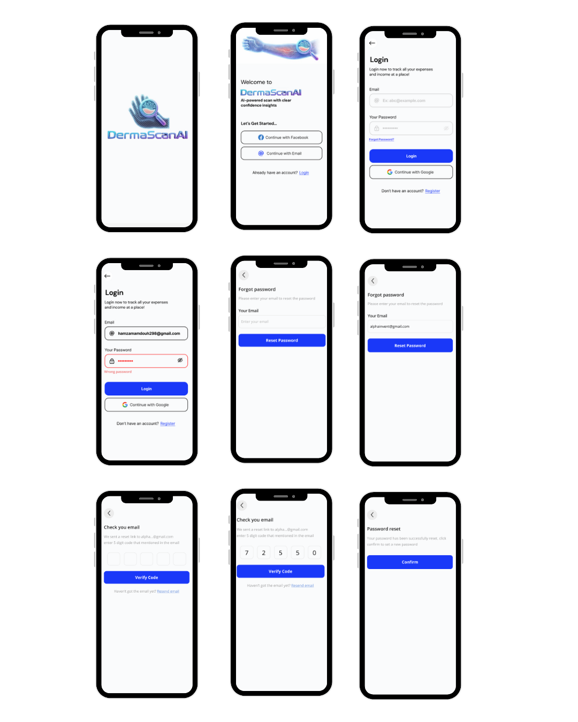
Figure 42 Welcome Page

Welcome to
this page show to you that you can register by two ways facebook or
google email or if you have account click login.

Figure 43 Welcome To Page

Login
to login the app need the email and your password to login or
login by google and you can create account by clicking on
register.

Figure 44 Login Page

Forget password
f you forget your password you need to enter your email to and it will send to you a verification code (5 digits ) to your email to reset your password.



Figure 45 Forget Password Page

Recreate new password
after you write your code correctly you can write the new password and confirm it after doing it correctly a splash screen with message (successful with icon ) with update password button after click on it the password will changed.
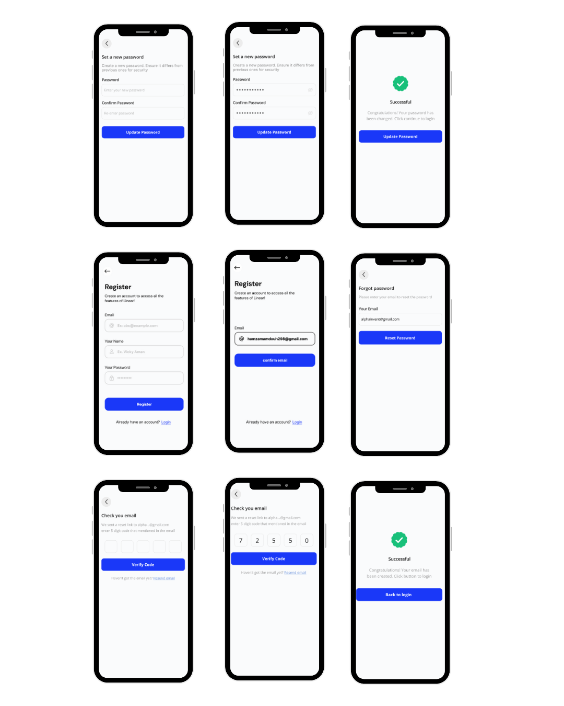
Figure 46 Recreation Password

Register
create account if you don’t have and the user provide details information
(full name,email and password).

Figure 47 Register Page

Confirm email
the app will send to the email acode (5digit) to confirm that its your email and after you verify code the splash screen with successful message and successful logo will show with back to login button to login.

Figure 48 Confirm Mail

Homepage
hompage of the app for new user show that your lesions is empty ,you can
choose the Date by months and weeks, add lesion button with blue icon (hand
and AIscan) and navebar with three main buttons ( home - lesions – profile ) and
the icon with blue color mean the location page.

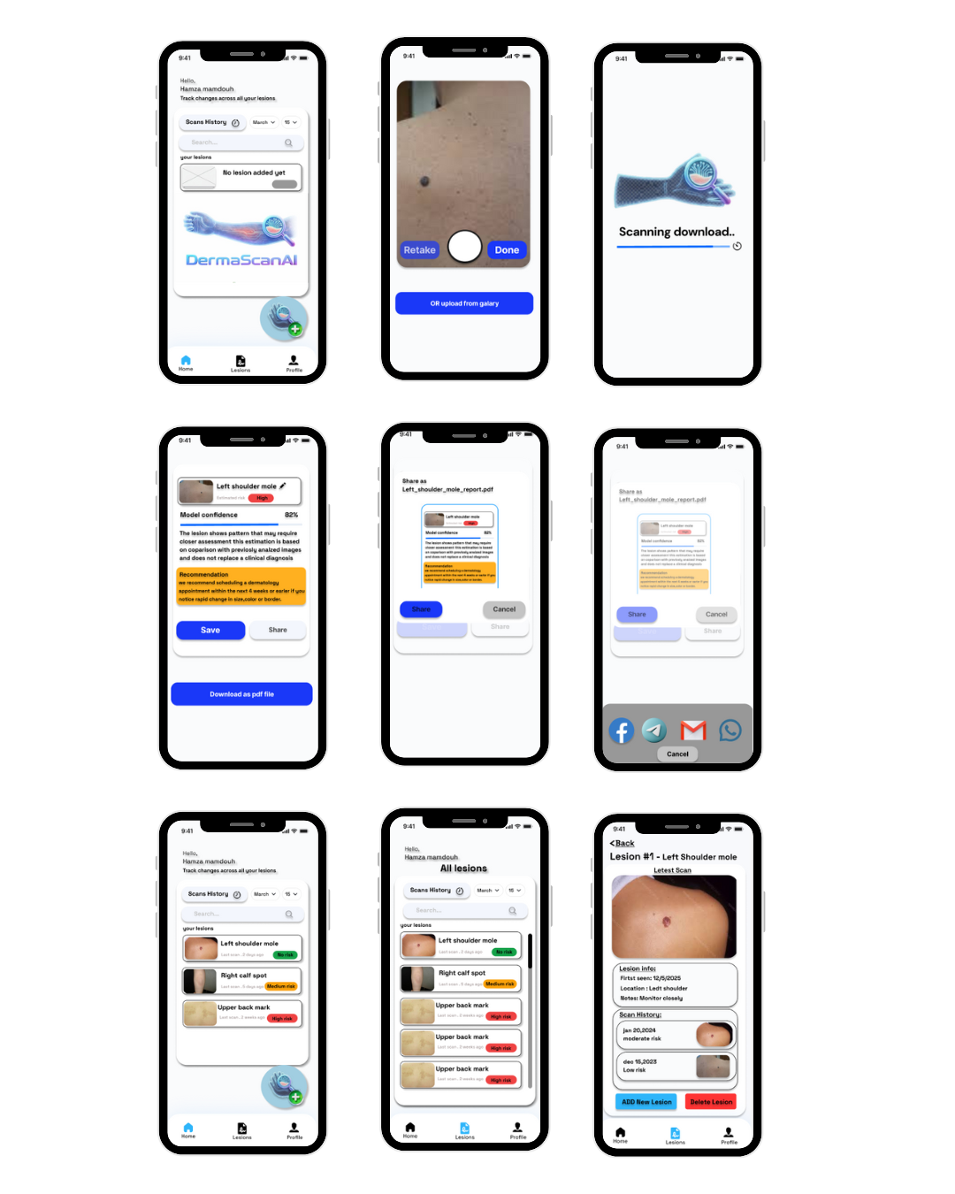
Figure 49 Homepage

scan
you will take alive picture of your skin and the AI detect
will take few time to detect it.

Figure 50 Scan Page

AI detect details
after the AI detect it successfully the header show that the image and the name
that you can edit it and color rate of danger (green – orange - red) and it will
provide with percentage of moldel confidence and give you some important
details you can save, share or download it as pdf file.

Figure 51 Detailed Page

Share
you can share it as pdf file to many social media (telegram ,
whatsapp , gmail. etc..).

Figure 52 Share Page

Lesions
the lesions page show that all your lesions and you can filter
it by the date or you can search it by the name and if you click
on one of it you can see the lesion information like image
or important details and you can add new lesion to it or just
delete it

Figure 53 Lession Scaned Page

Confirm delete
after click on delete the splash screen with message (are you sure you
want to delete ) and two buttons with delete and cancel after delete
a notification that send to you with information of lesion name and time
of deletion
. 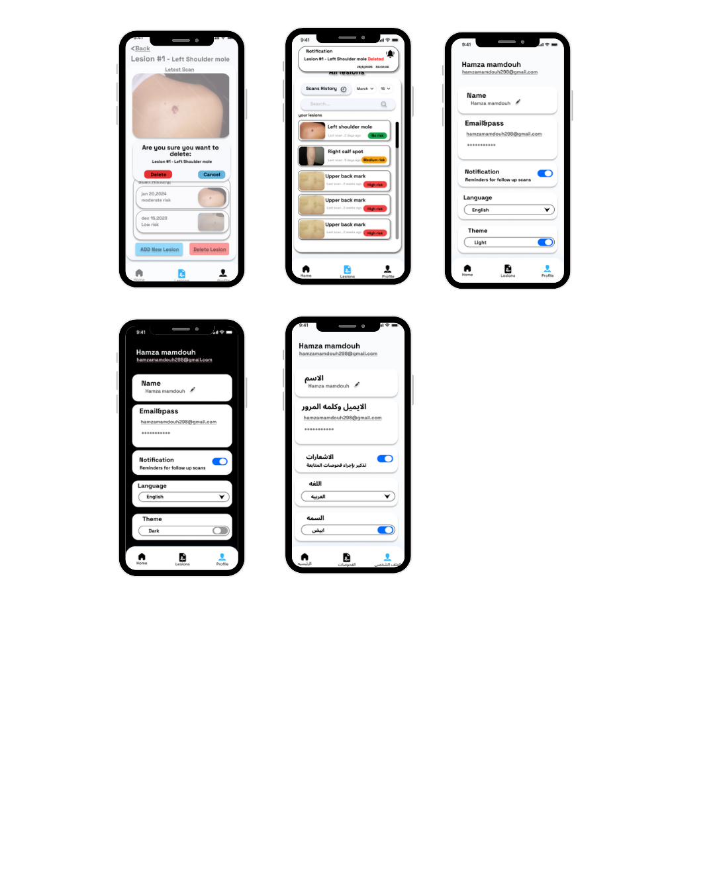
Figure 54 Access Scanned Lession

Profile page
show the information (name ,email and password) and you
can edit it and enable or disable notification and you can change
language and change the them
. 

Figure 55 Profile Page

Mood
you can change language (Arabic or English) and change the them light or dark as you like


Figure 56 Mood Page

Conclusion and Future Work

Conclusions
The project demonstrated the potential to create a mobile app, a backend system, and an artificial intelligence (AI) engine that use machine learning (ML) and deep learning (DL) algorithms to help doctors diagnose melanoma earlier. The prototype developed illustrated how an image of a possibly cancerous lesion could lead to an accurate diagnosis. The lesion was really easy to see because the segmentation model was very good, at finding the edges of the lesion. The segmentation model did a job of locating the edges of the lesion. And the classification model was accurate Additionally the prototype showed that skin cancer detection tools using AI can be made easy to use and accessible. These tools can help doctors by giving them help with early detection. This can reduce the workload of healthcare professionals. The prototype is a starting point for creating even better tools to assist with diagnosis. Reliable skin cancer detection tools are helpful for doctors. They can use these tools to find skin cancer. Early detection is key, to treating skin cancer.

Future Work:
To make things better in the future we can try a different things, including:
- It is hard to get a lot of data but the goal of future improvements is to have a big database that has samples, from many different ethnic groups and skin colors and this big database will help with future improvements.
- Investigating alternative network architectures (such as EfficientNet, Vision Transformers and CNN-Transformers) that could be used to improve accuracies.
- Using pictures to explain how our Artificial Intelligence models work, like Grad-CAM and attention maps will help doctors and patients understand them better. This will make the clinical community and patients trust our Artificial Intelligence models more.
- Developing a method to analyze images taken in real-time on mobile devices and allow for model execution on smartphones.
- We are working on an app that can detect more, than just melanoma it can also identify other skin conditions using technology.
- Our goal is to make our user interface better we want to make it more friendly and easy to use for our users that way they can easily access what we offer.
- Performing validation studies with dermatologists and in a clinical environment and among test subjects.
- Creating a cloud-based training, monitoring and continually updating the models

References
[1] Bhatt, P., Kumar, V.,, & Kaur, R. (2023). State-of-the-art machine learning techniques for melanoma skin cancer detection and classification: A comprehensive review. International Journal of Imaging Systems and Technology.
[2] G. Arango-López, S. Hernández-Leal, J. M. A. Maestre, and F. L. G. Peñaranda, "A systematic review on artificial intelligence and digital twins for smart manufacturing," Neural Comput & Applic, Jan. 2023.
[3] Anjum, R. M., Maqsood, A., Zafar, F., and Malik, F., 2019. Review on smart sensors for air pollution monitoring. Health Technol., 9(6), pp. 693–698.
[4] Shinde, K. A., and Patil, S., 2024. A review of image captioning using deep learning models. Cogent Engineering, 11(1).
[5] VIVASCOPE, "Early Detection of Skin Cancer," VIVASCOPE Knowledge Base, 2024, [Online]. Available: https://www.vivascope.com/knowledge-base/early-detection-of-skin-cancer/.
[6] S. Ghosh, S. Dhar, R. Yoddha, S. Kumar, A. K. Thakur, and N. D. Jana, "Melanoma Skin Cancer Detection Using Ensemble of Machine Learning Models Considering Deep Feature Embeddings," Procedia Computer Science, vol. 235, pp. 3007–3015, 2024.
[7] C. Supriyanto, A. Salam, J. Zeniarja, D. W. Utomo, I. N. Dewi, C. Paramita, A. Wijaya, and N. Z. M. Safar, "A Bibliometric Review of Deep Learning Approaches in Skin Cancer Research," Computation, vol. 13, no. 3, p. 78, Mar. 2025.
[8] A. Adegun and S. Viriri, "Deep learning techniques for skin lesion analysis and melanoma cancer detection: a survey of state-of-the-art," Artificial Intelligence Review, vol. 54, pp. 811–841, 2021.
[9] A. Tajerian, M. Kazemian, M. Tajerian, and A. A. Malayeri, "Design and validation of a new machine-learning-based diagnostic tool for the differentiation of dermatoscopic skin cancer images," PLOS ONE, vol. 18, no. 4, p. e0284437, Apr. 2023.
[10] D. Popescu, M. El-Khatib, H. El-Khatib, and L. Ichim, "New Trends in Melanoma Detection Using Neural Networks: A Systematic Review," Sensors, vol. 22, no. 2, p. 496, Jan. 2022.
[11] Y. Wu, B. Chen, A. Zeng, D. Pan, R. Wang, and S. Zhao, "Skin Cancer Classification With Deep Learning: A Systematic Review," Frontiers in Oncology, vol. 12, p. 893972, Jul. 2022.
[12] A. A. Meshram, A. Gade, and A. Dutonde, "A Review of Skin Melanoma Detection Based on Machine Learning," International Journal of New Practices in Management and Engineering, vol. 11, no. 2, pp. 15–23, Feb. 2022.
[13] R. Kaur, H. Gholami-Hosseini, R. Sinha, and M. Lindén, "Automatic lesion segmentation using atrous convolutional deep neural networks in dermoscopic skin cancer images," BMC Medical Imaging, vol. 22, no. 1, p. 103, May 2022.
[14] A. Pandey, S. Degadwala, and D. Vyas, "A Review on Transfer Learning Approaches for Skin Melanoma Classification," International Journal of Scientific Research in Computer Science, Engineering and Information Technology, vol. 8, no. 6, pp. 394–399, Dec. 2022.
[15] P. Nghiem, S. Bhatia, E. J. Lipson, W. H. Sharfman, R. R. Kudchadkar, A. S. Brohl, P. A. Friedlander, A. Daud, H. M. Kluger, S. A. Reddy et al., "Durable Tumor Regression and Overall Survival in Patients With Advanced Merkel Cell Carcinoma Receiving Pembrolizumab as First-Line Therapy," Journal of Clinical Oncology, vol. 37, no. 7, pp. 693–702, Mar. 2019

